**Packet Sniffing and Spoofing Lab**

Contents

Environment Setup 3

Task 1 4

Task 1.1 8

Task 1.1A 8

Task 1.1B 13

Task 1.2 22

Task 1.3 24

Task 1.4 26

Task 2 32

Task 2.1 33

Task 2.1A 34

Task 2.1B 36

Task 2.1C 40

Task 2.2 44

Task 2.2A 44

Task 2.2B 46

Task 2.3 48

# Environment Setup

Setting up Dockers.

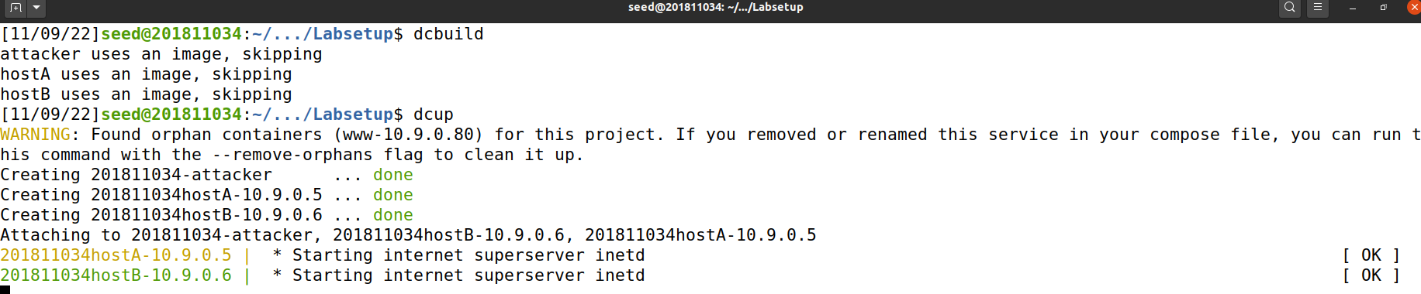

Checking Available Dockers.

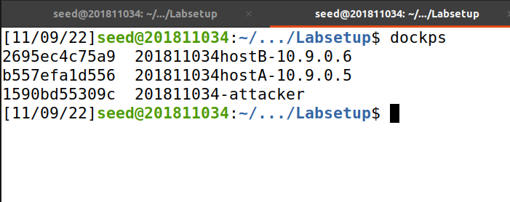

Setting up Attacker Terminal.

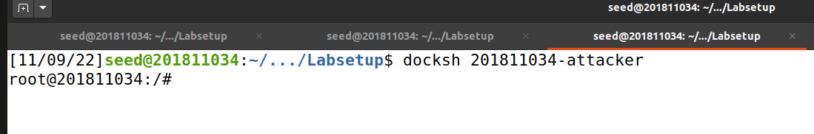

Setting up HostA Terminal.



Setting up HostB Terminal.



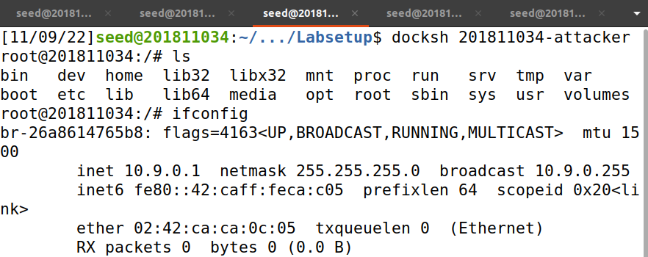

# Task 1

Ran the commands given in the manual and we get the IP details of the packet.

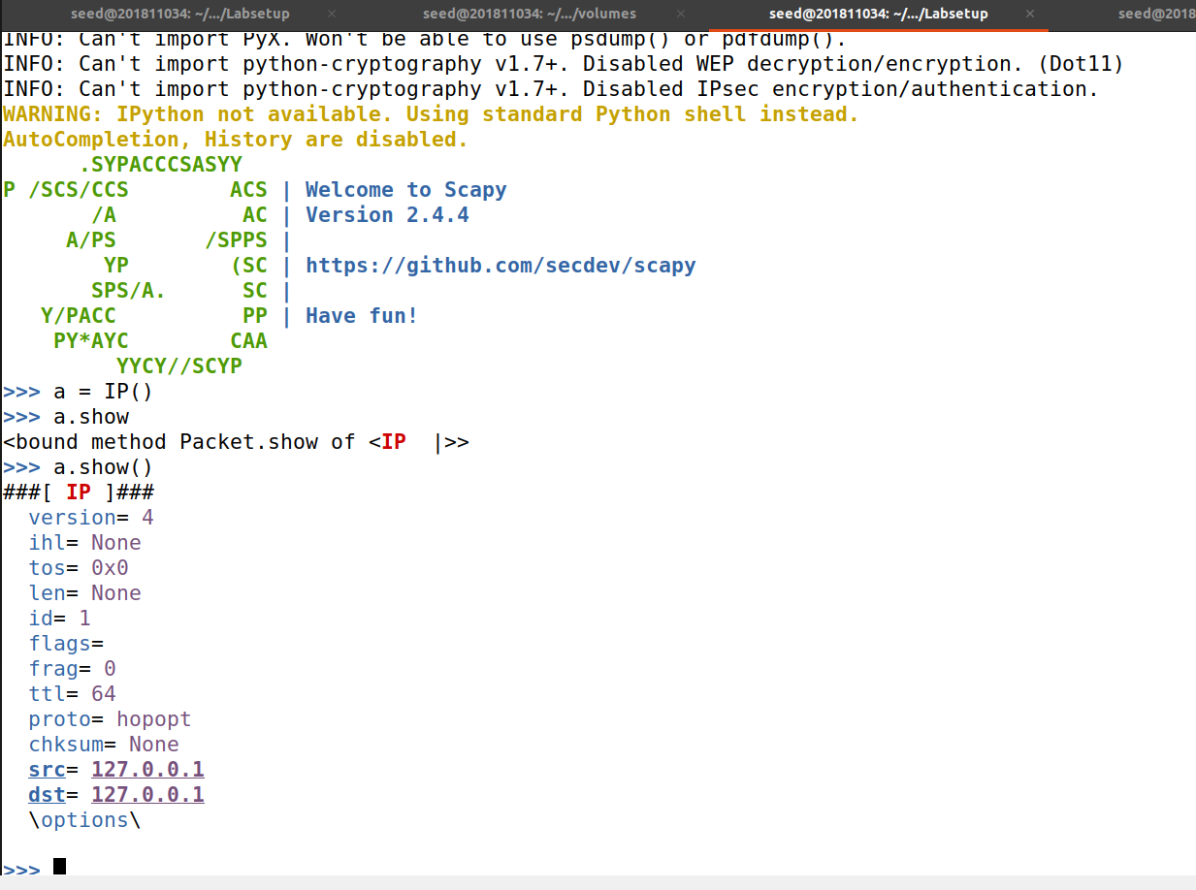

Wrote a script as the tasks were performed manually will be done automatically with the script.

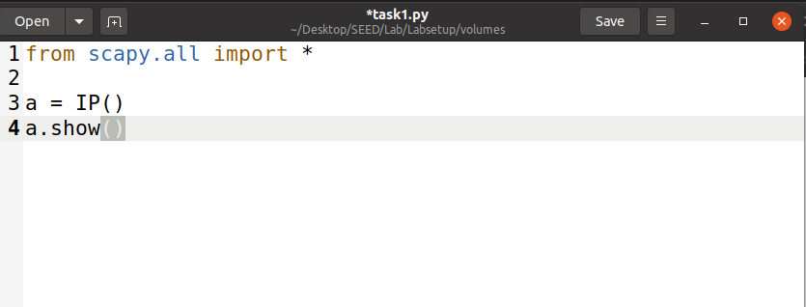

Now executing the script and we see that it is running the same way we did manually.

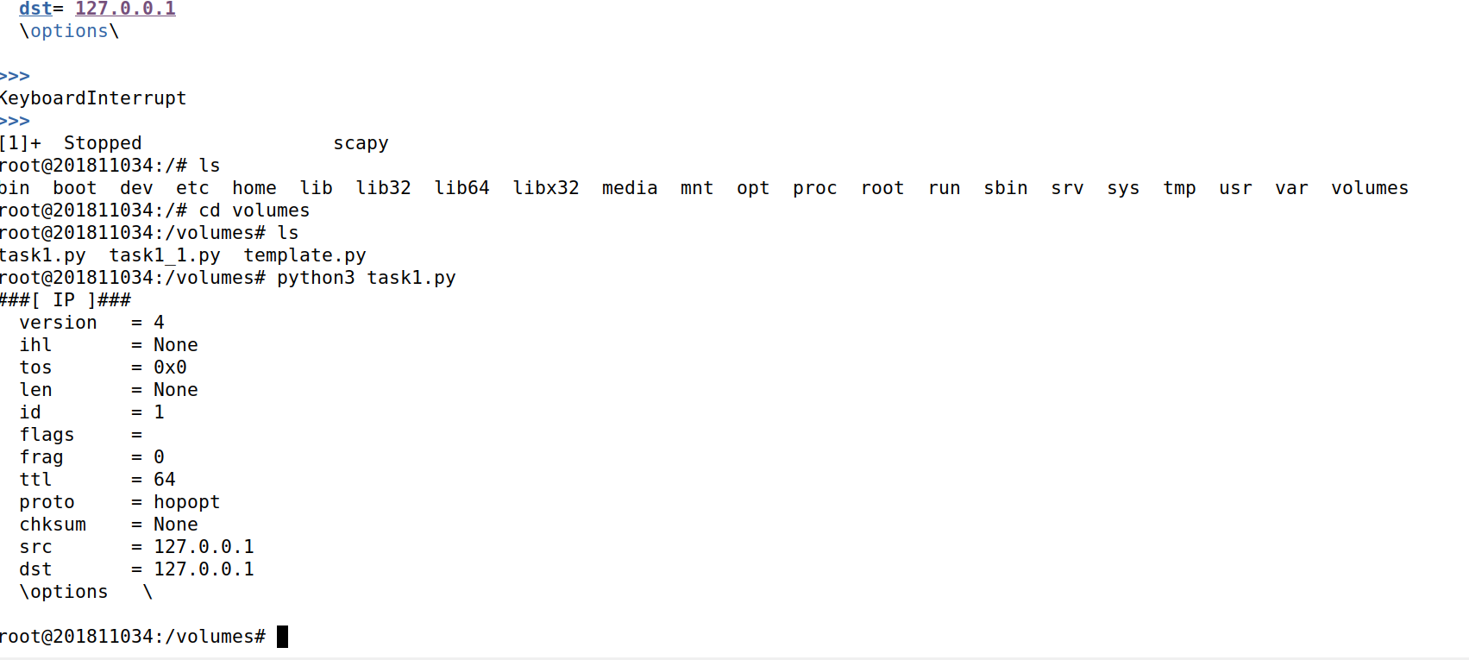

Now making the script executable and confirming which it evidently becomes as shown in the screenshot.

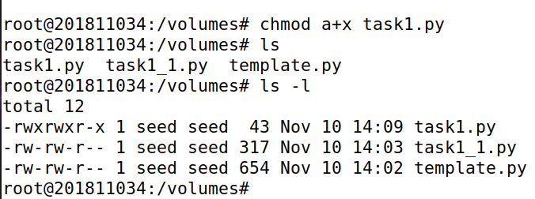

When confirming in host is also shows it is executable now.

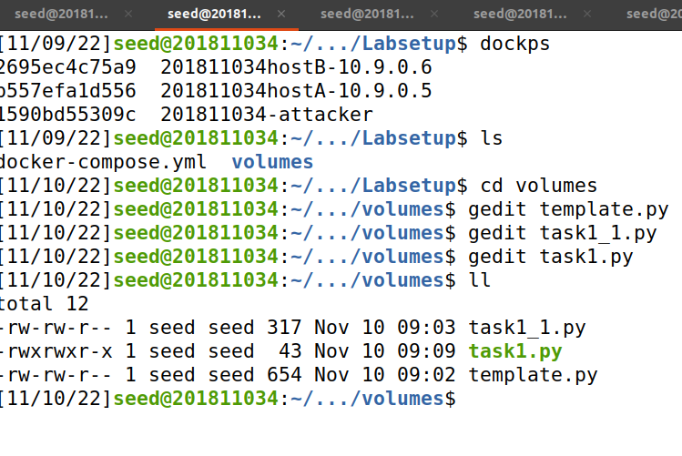

Now trying the way taught in manual if we need to change the code frequently.

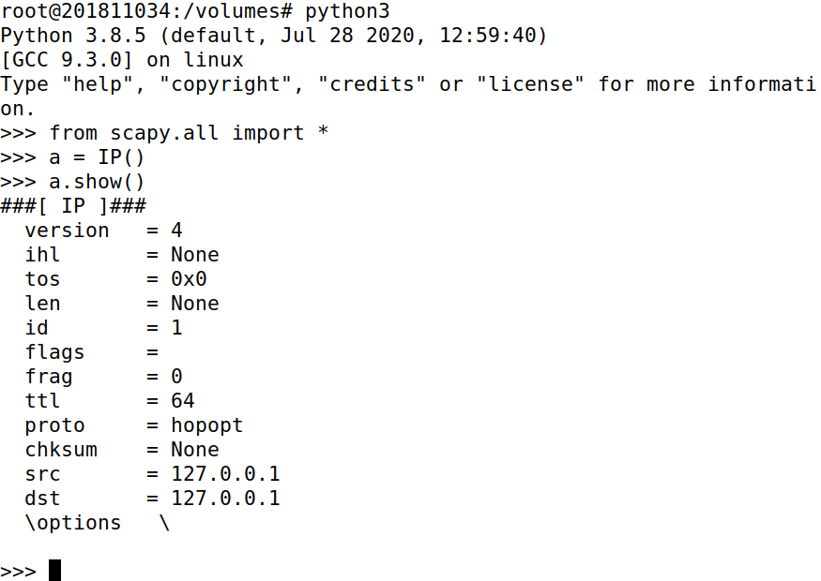

## Task 1.1

Creating python files in **volumes** via host to perform the task while setting interface to the one found above in the Environment Setup.

Now changing the file to executable and launching the code.

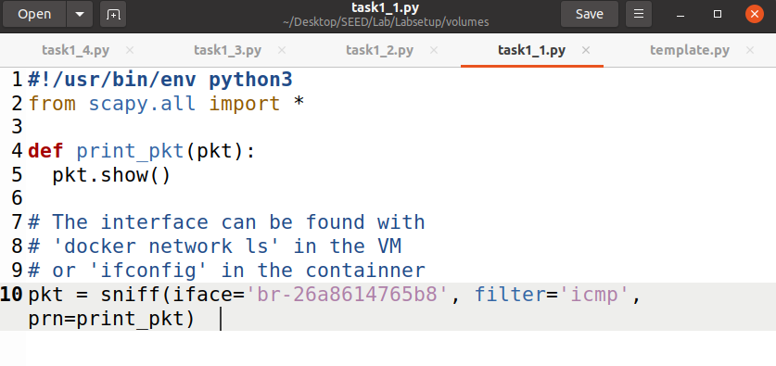

### Task 1.1A

Making the code file for the task executable and launching the code from which we can see there was an error which was fixed after I added the part in line 1 as shown in the screenshot above. After that I observed that the code is now sniffing so I moved to test if it is working.

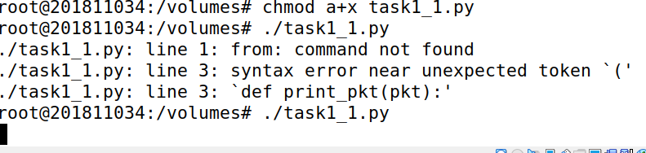

Sending the packets from HostA to HostB.

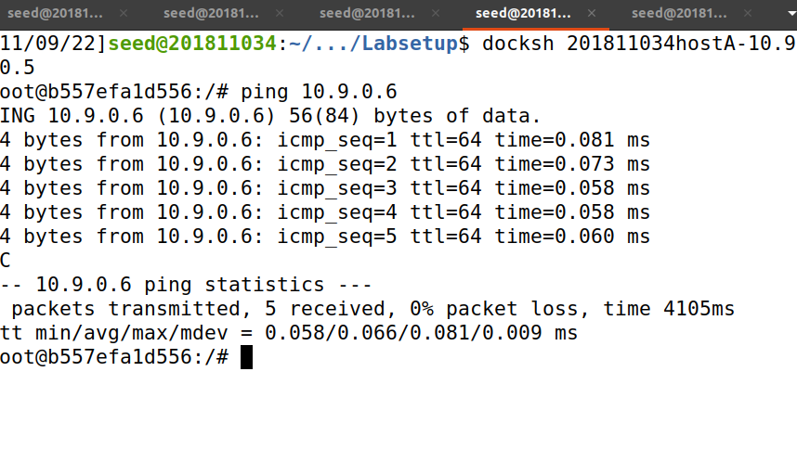

As evident in the attacker terminal the packets have been sniffed.

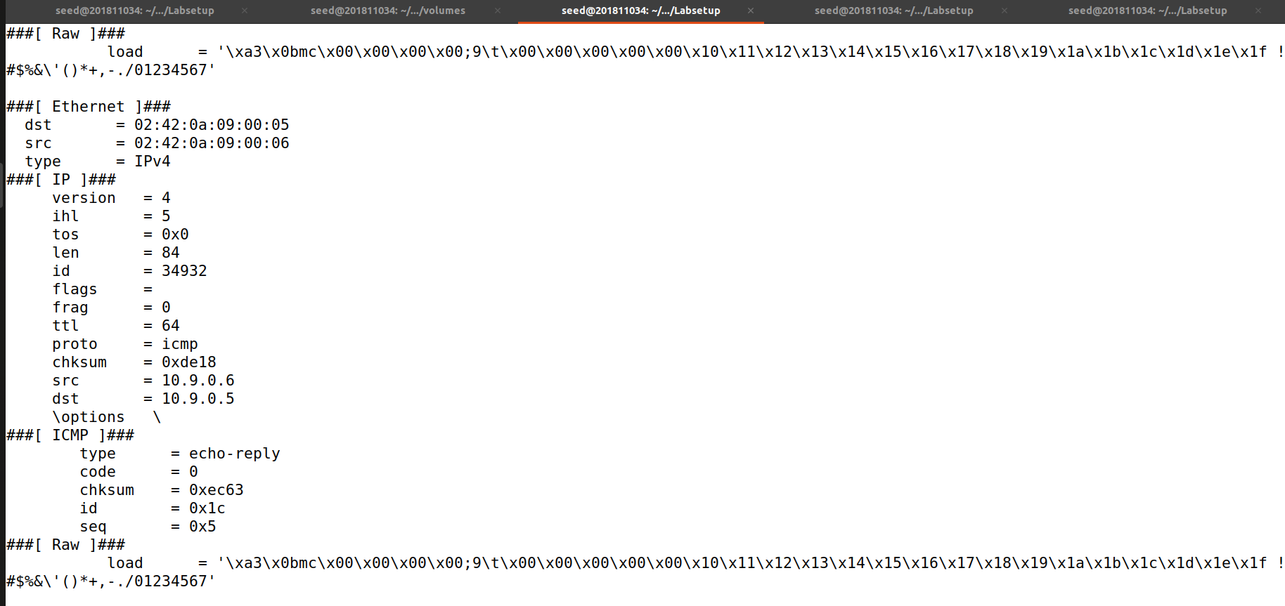

Modified the previous code in order to see the number of packets received and now running as seed user.

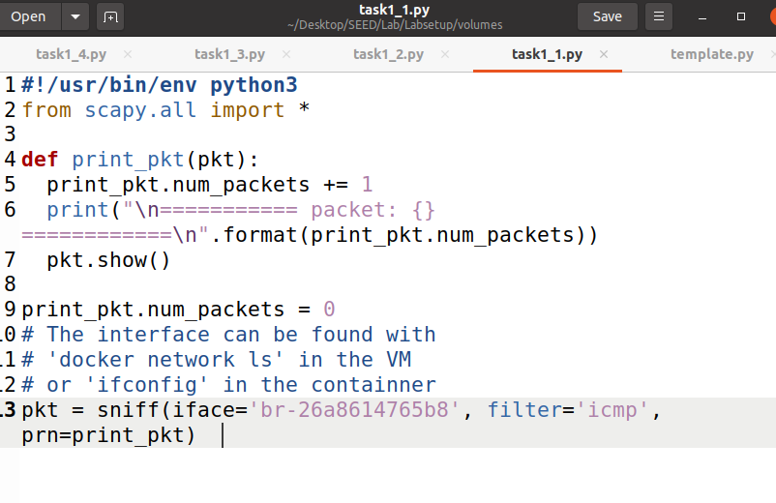

While running as normal seed user I couldn’t get the permission to launch the script.

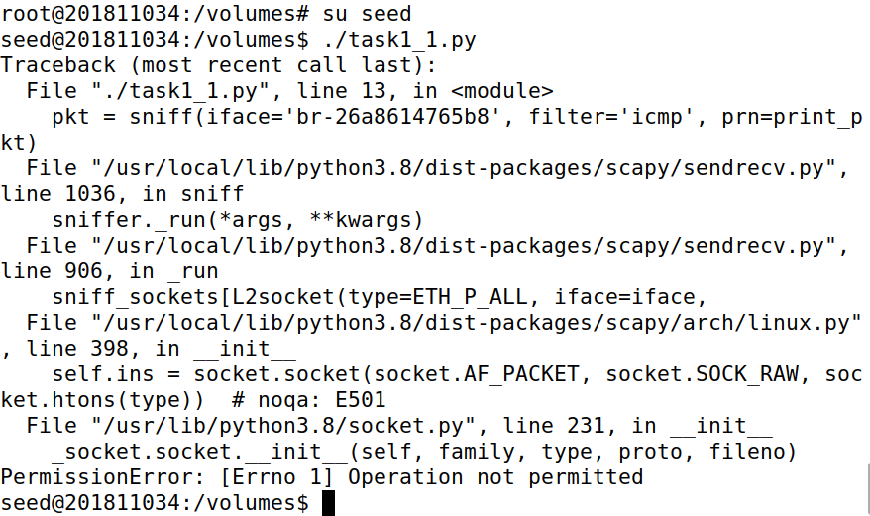

Launching the script.



Again sending the packets from HostA to HostB.

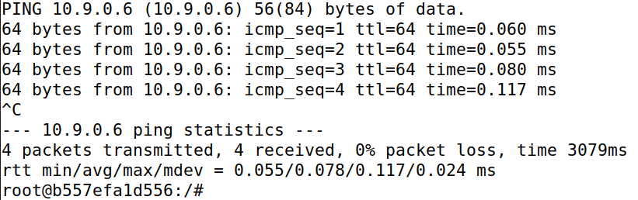

Now we see the packet numbers being displayed indicating 8 packets as 4 were transmitted and 4 received as it is visible in the above screenshot. Therefore, our code sniffed total 8 packets.

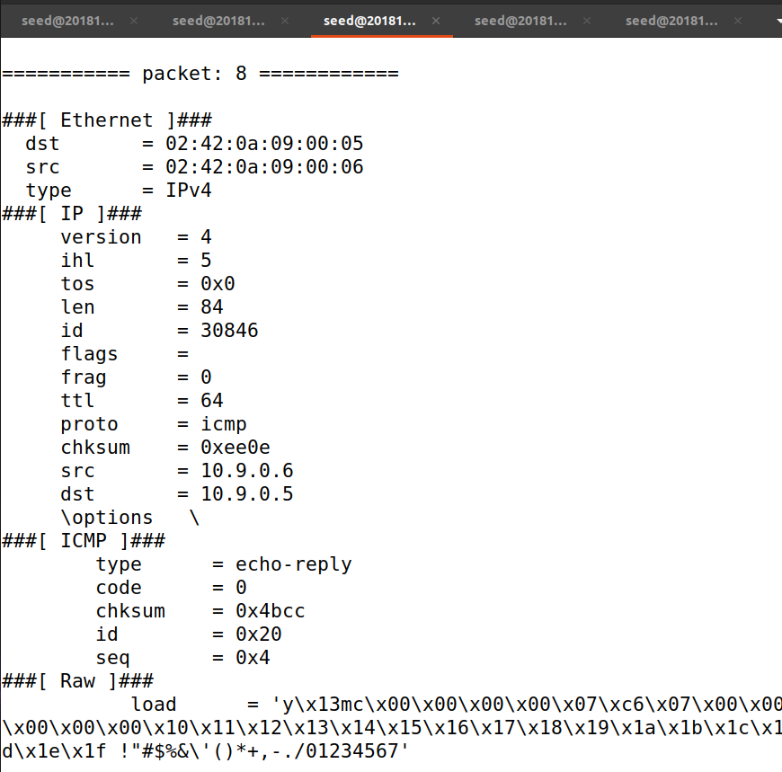

### Task 1.1B

#### Capture Only ICMP Packets

Using the previous screenshots as we caught the ICMP Packets only in that.

Modified the previous code in order to see the number of packets received and now running as seed user.



While running as normal seed user I couldn’t get the permission to launch the script.



Launching the script.



Again sending the packets from HostA to HostB.



Now we see the packet numbers being displayed indicating 8 packets as 4 were transmitted and 4 received as it is visible in the above screenshot. Therefore, our code sniffed total 8 packets.



*Capture any TCP packet that comes from a particular IP and with a destination port number 23*

Modifying the code in order for it to capture only TCP packets while providing source IP and destination port.

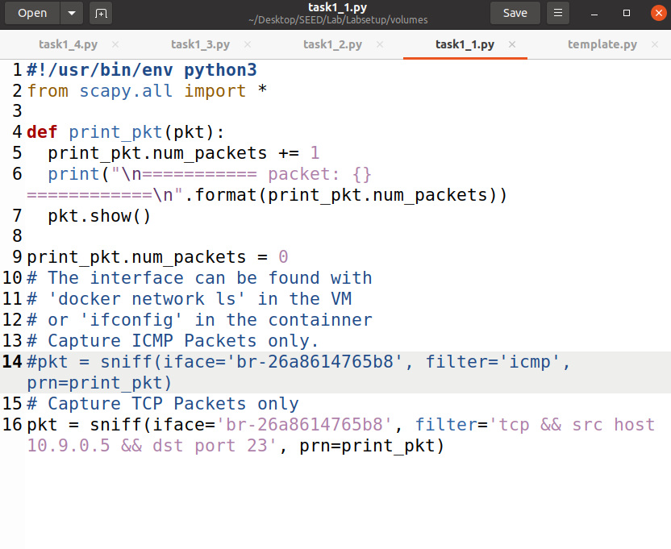

Connecting HostA with HostB via telnet the TCP port.

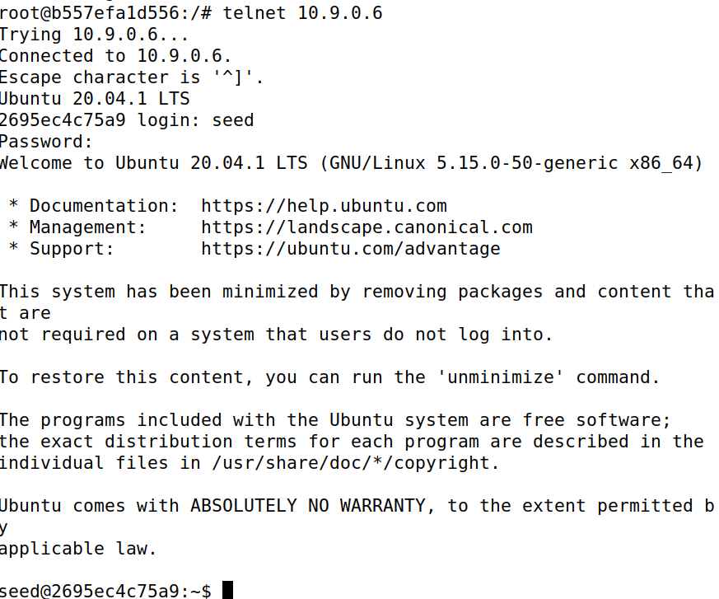

Now in the attacker terminal we can see the TCP packets being captured from HostA to HostB.

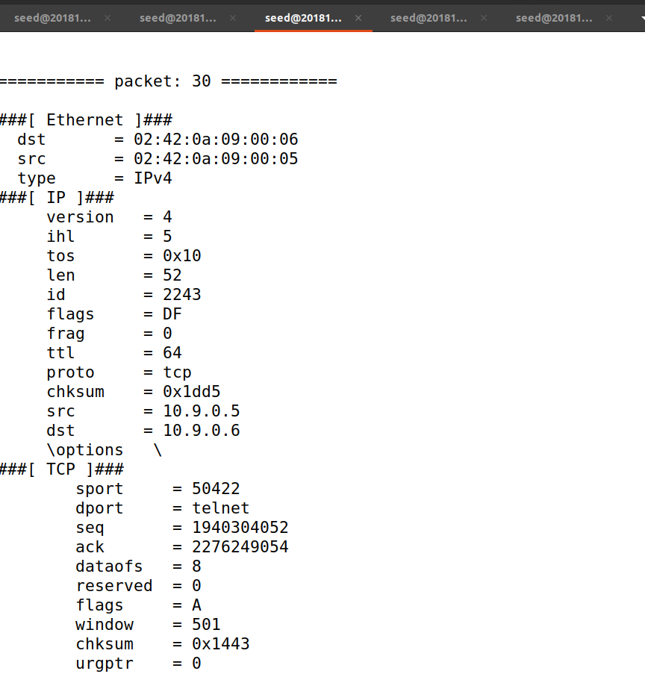

#### Capture packets comes from or to go to a particular subnet. You can pick any subnet, such as 128.230.0.0/16; you should not pick the subnet that your VM is attached to

Modifying the code to the need of the task.

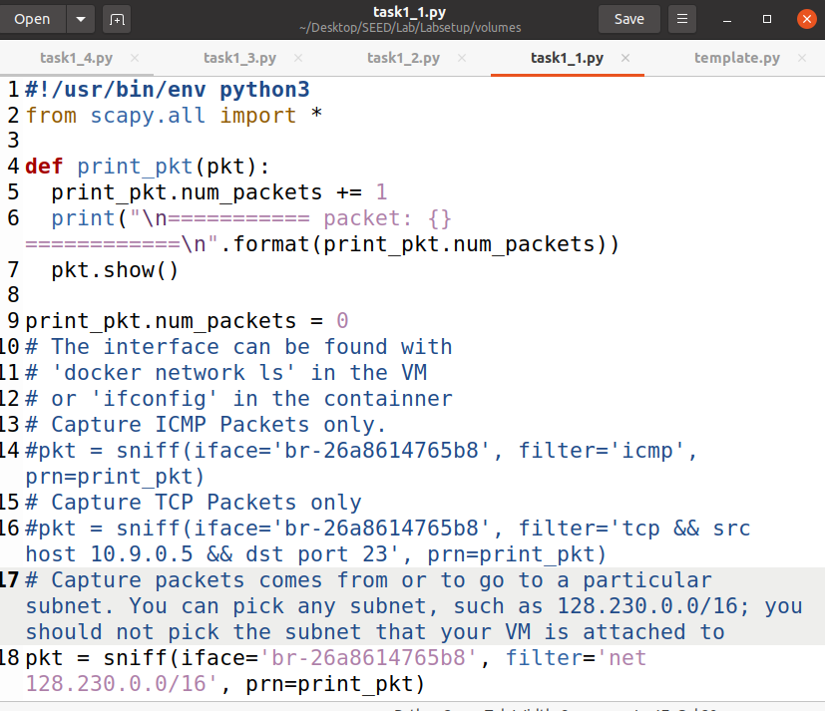

Launching the Script.

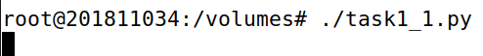

Closing the telnet connection between HostA to HostB and sending ping from HostA to an IP belonging in the respective subnet.

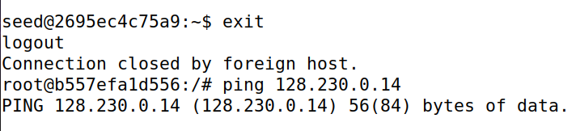

And so far I have caught 64 packets.

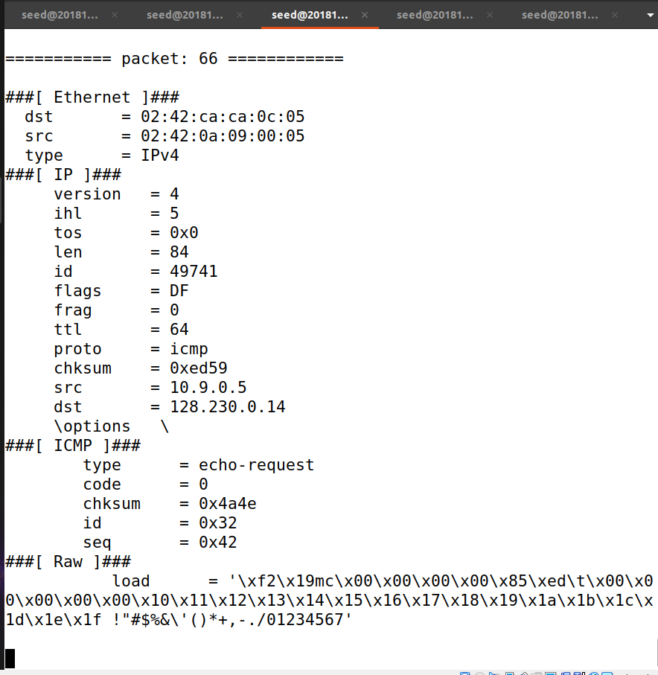

## Task 1.2

Here, I wrote a script as provided in the manual and modified a bit.

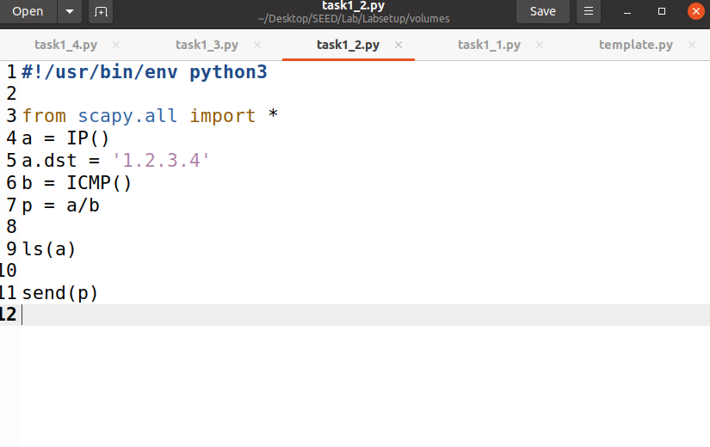

Setting up Wireshark.

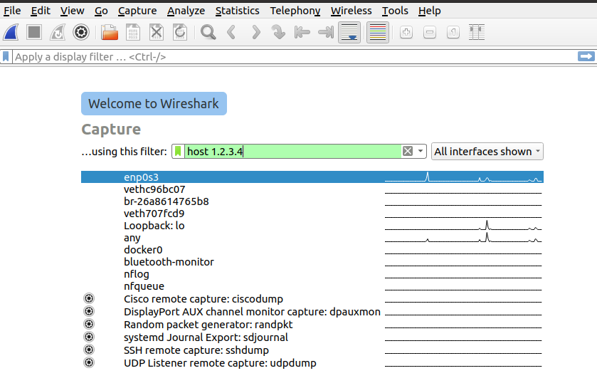

Making the script file executable and launching it makes it send a packet to the destination IP from Attacker Terminal.

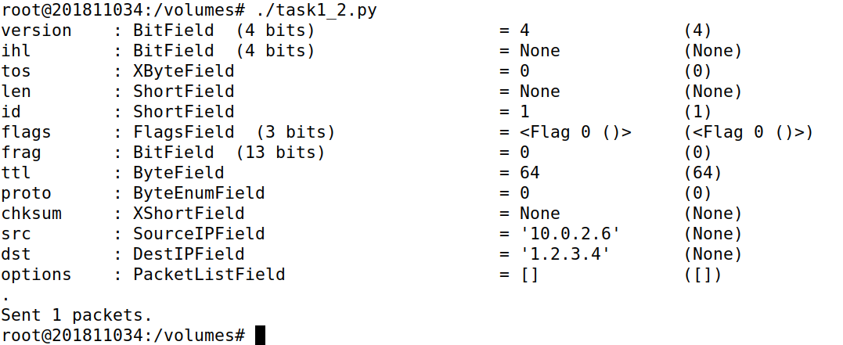

And we have caught our packet which is spoofed.

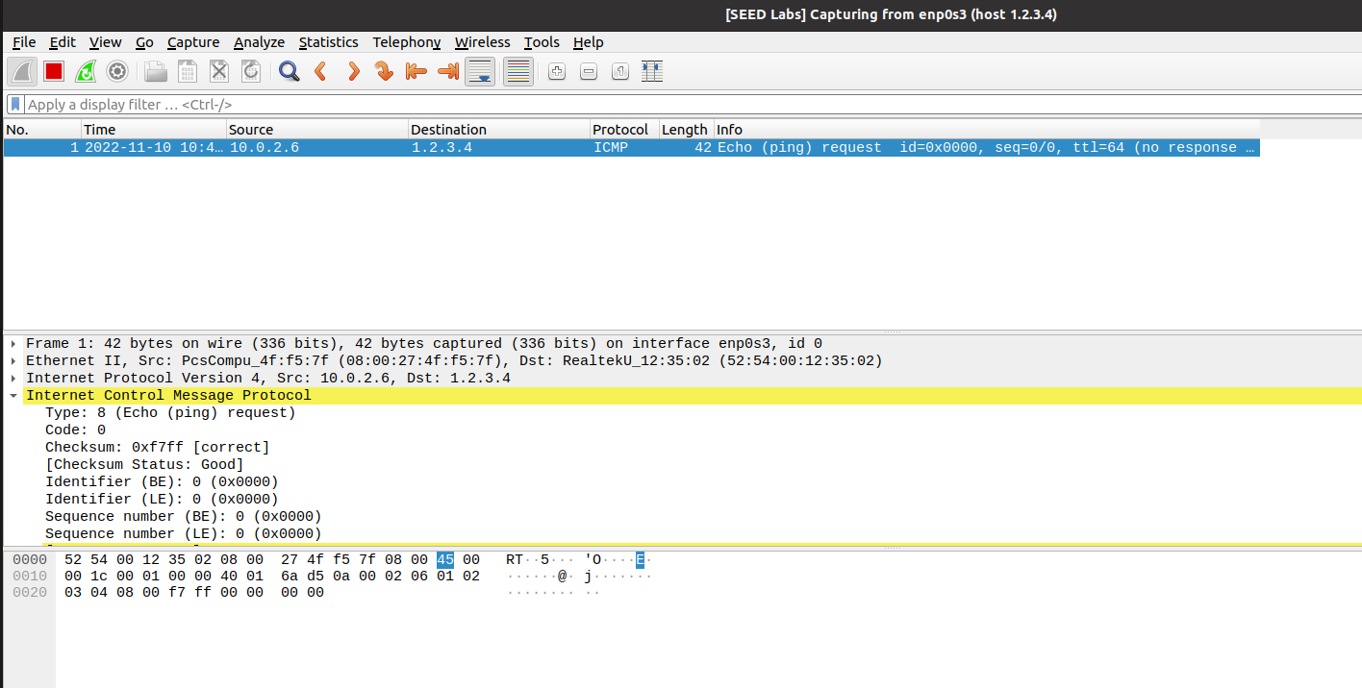

## Task 1.3

Now I wrote a script using the instructions provided in the manual for the task.

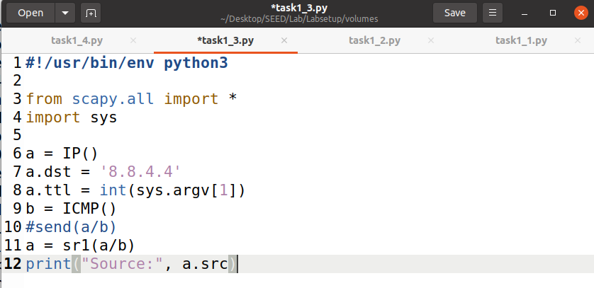

Now making the code executable and launching the attack manually with packet reference numbers.

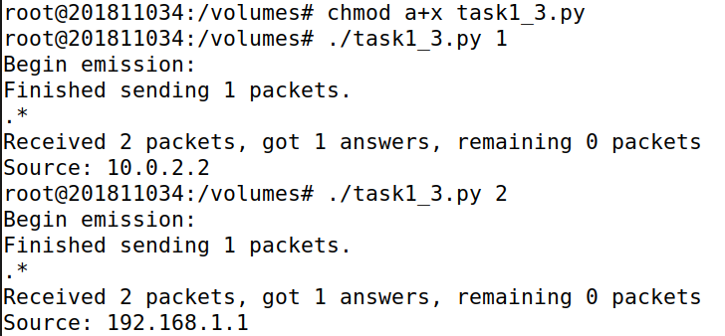

Here, after quite some packets we have reached the target IP address as source.

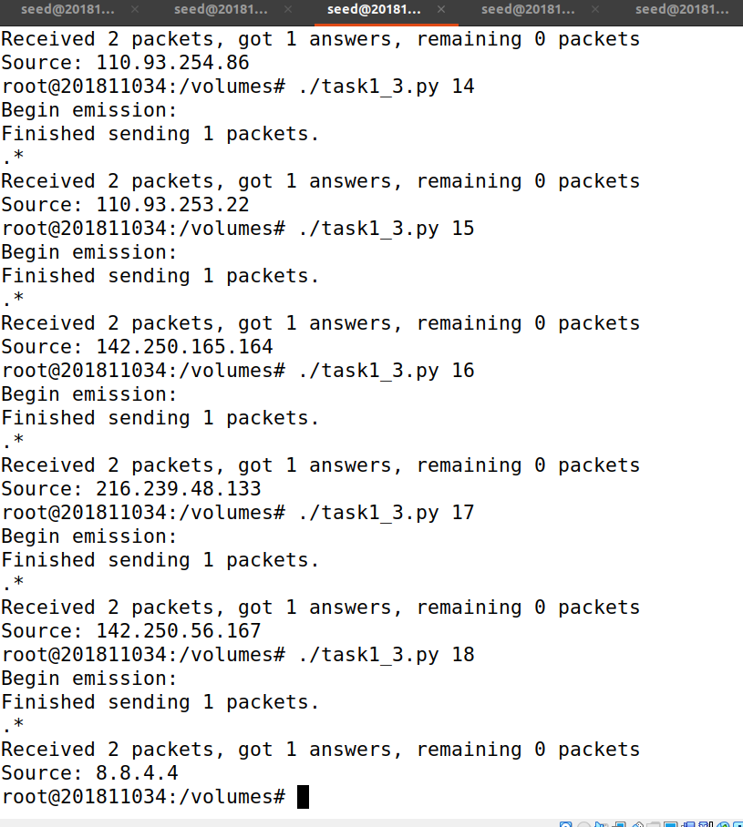

## Task 1.4

#### Non-existing host on the Internet

Here, I wrote a script for the purpose of sniffing and spoofing to target a non-existing host on the internet.

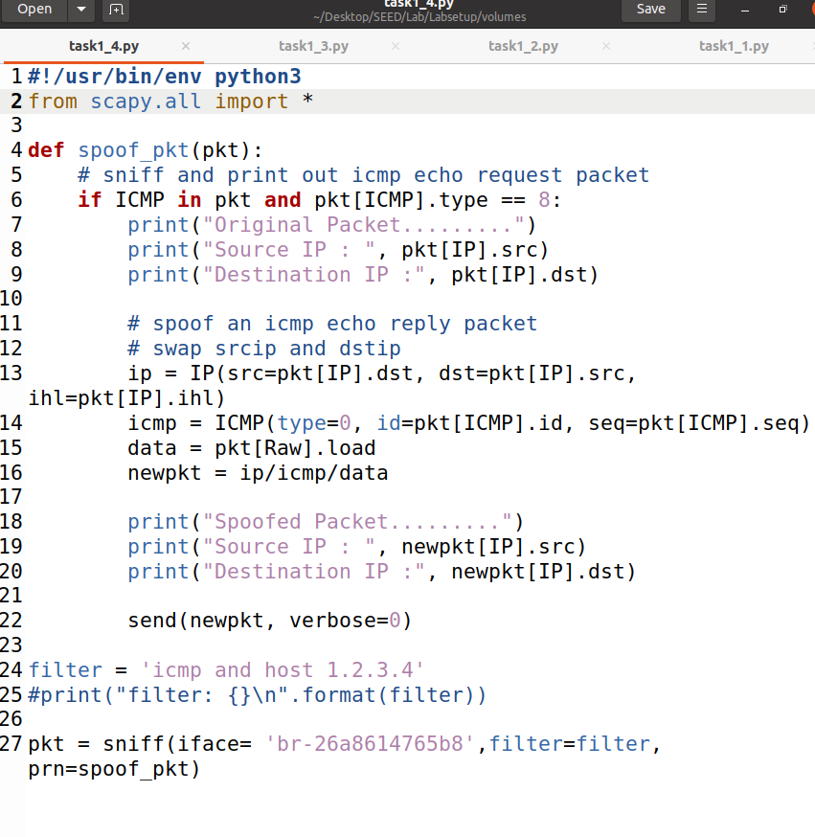

Initiating pinging process on the target from HostA.

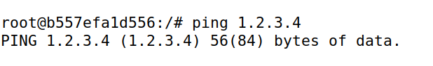

When I launched the script after making it executable, I started receiving a response.

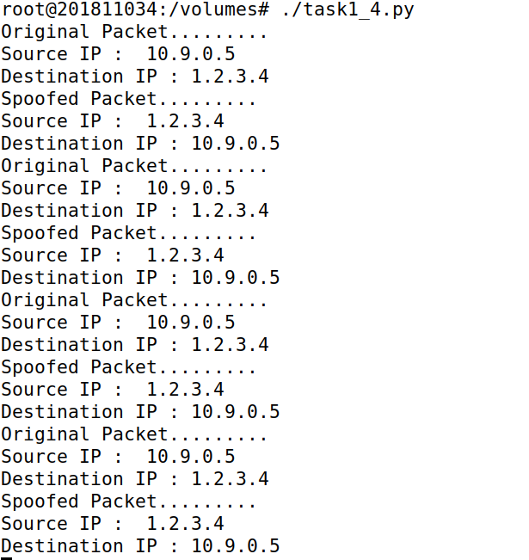

#### Non-existing host on the LAN

Modifying the code to perform the task on a non-existing LAN host.

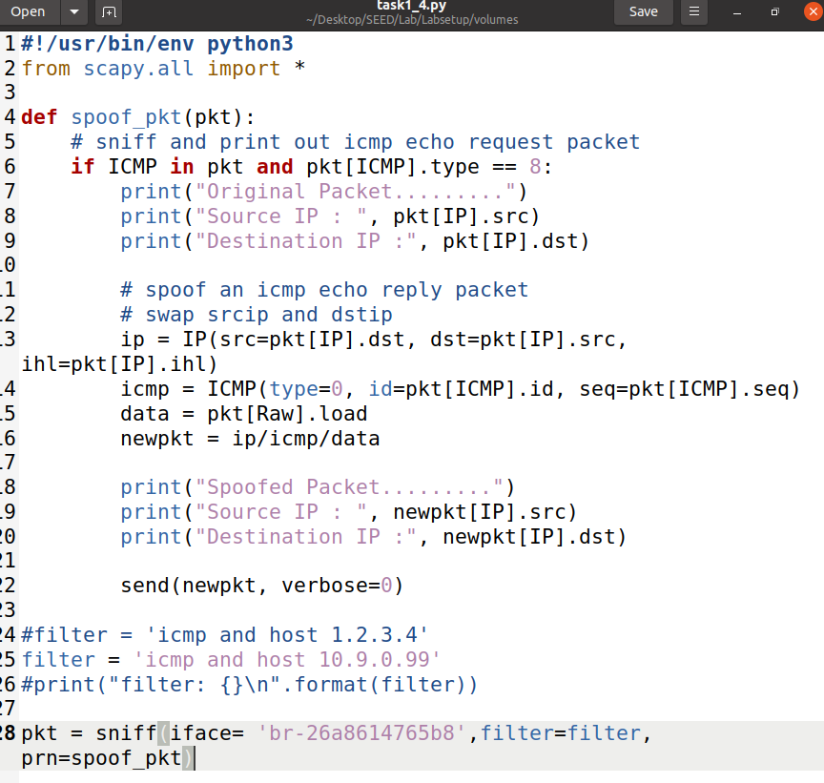

Launching the script in attacker’s terminal.

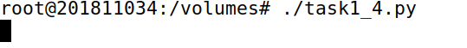

Initiating pinging process to the target but it is unreachable and no packet can be traced.

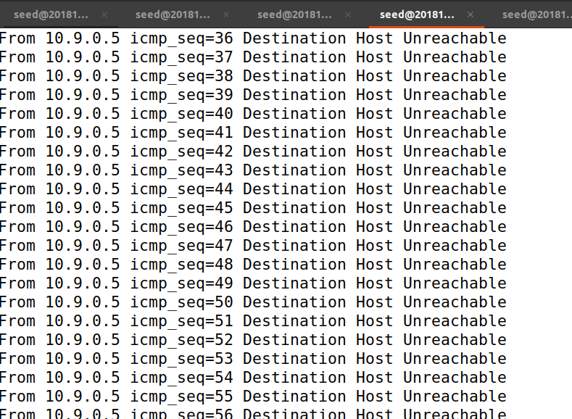

#### Existing host on the Internet

Modifying the script to target an existing Host on the internet.

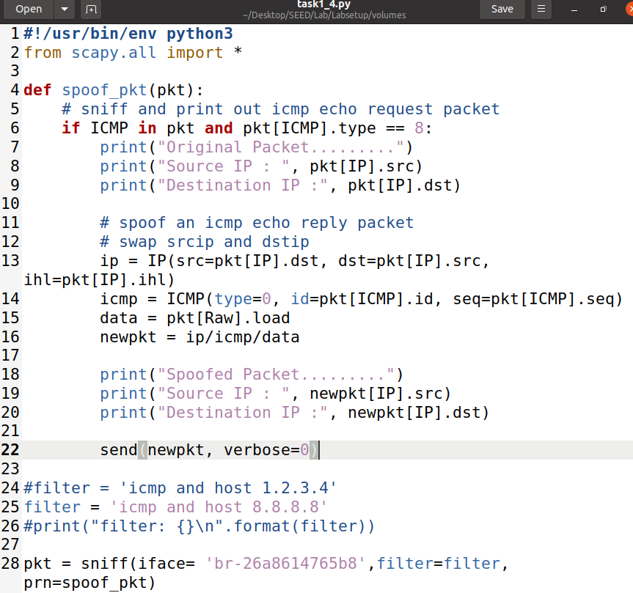

Launching the script in attacker’s terminal.

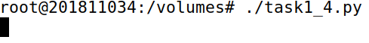

Initiating pinging the target.

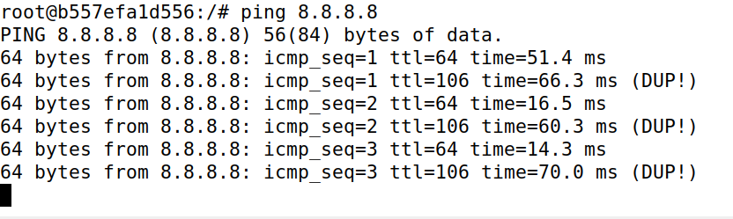

And we start seeing the packets sniffed and spoofed details.

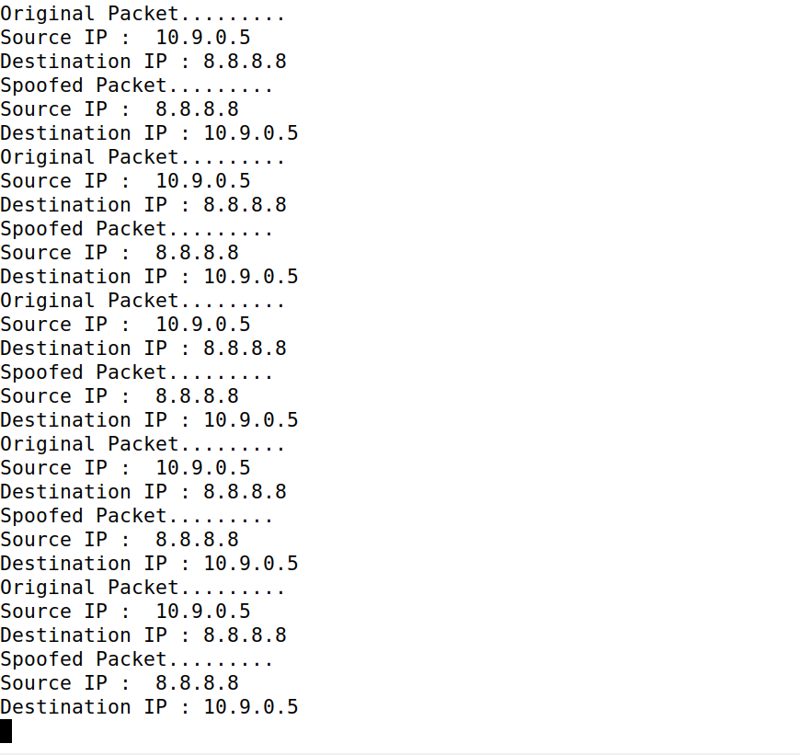

# Task 2

Creating more files for the upcoming tasks in the Host terminal.

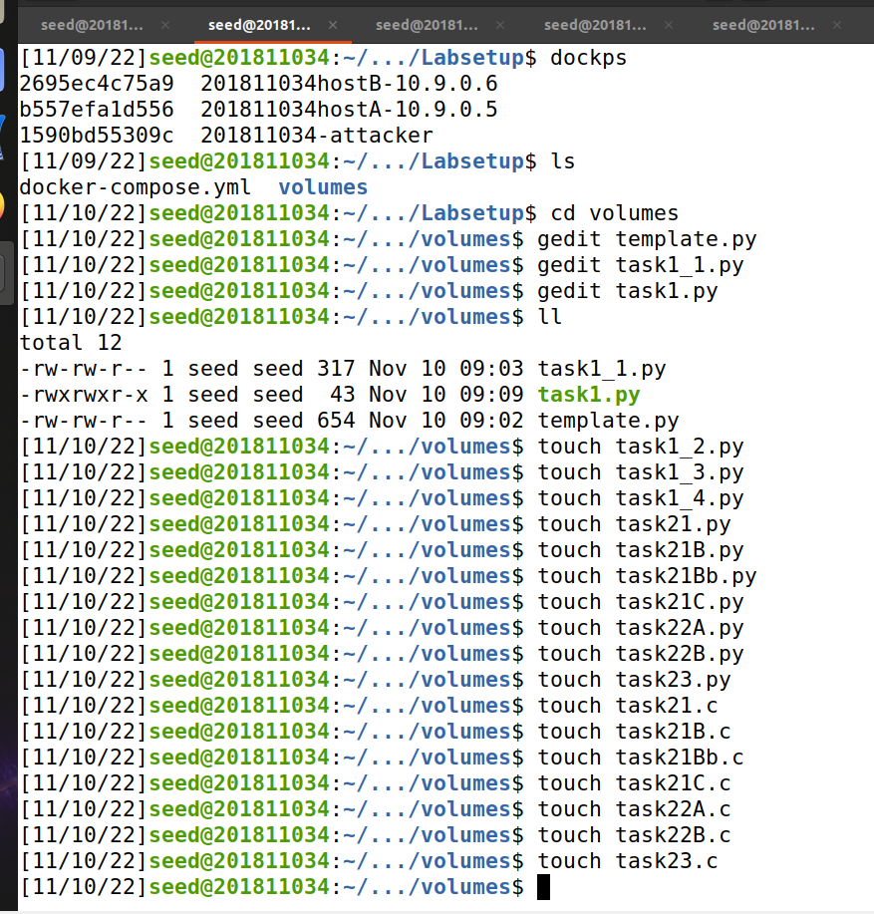

## Task 2.1

Wrote the code as per manual instructions for the sniffer.

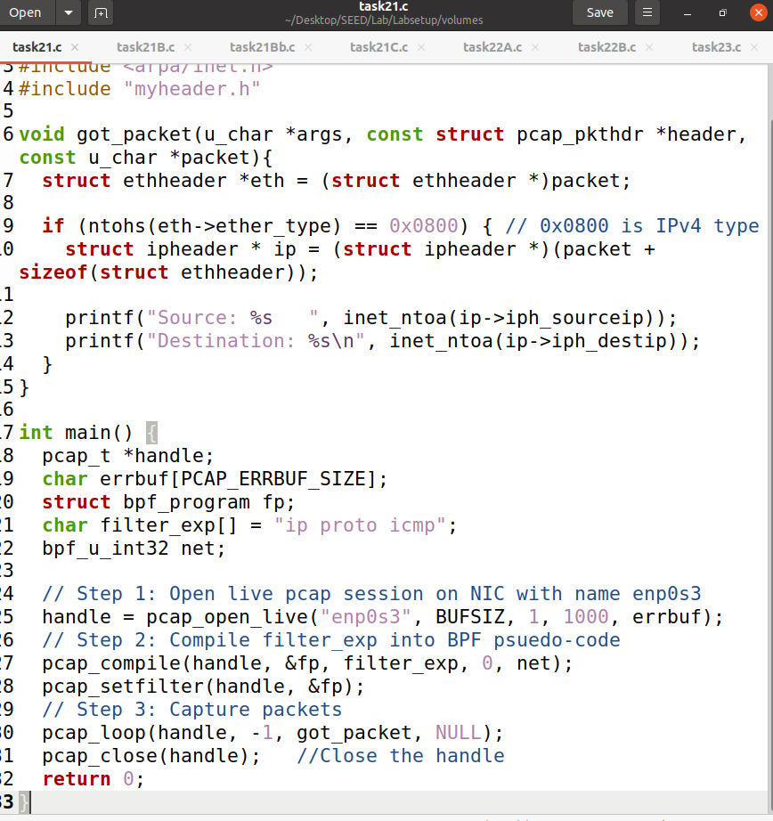

Using new terminals for the task. Moreover, Compiling and executing the sniffer.

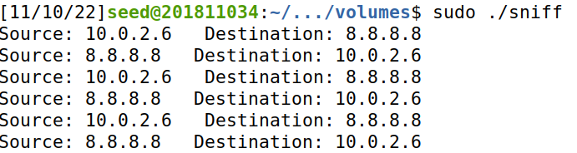

Sending 3 packets ping to 8.8.8.8

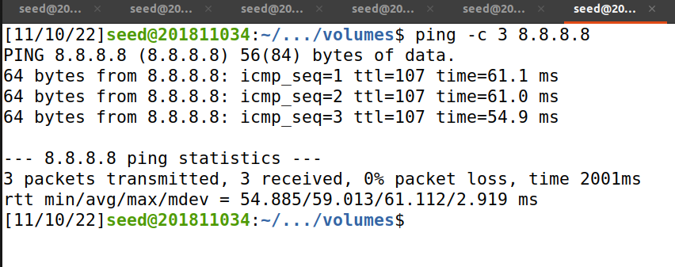

Checking back on the sniffer we get the results of those packets.



### Task 2.1A

#### Question 1

First I opened a live pcap session on NIC with name enp0s3, this operation is done by the *pcap_open_live* a function from the pcap library. Following function lets us see the whole network traffic in the interface and binds the socket. Second step, we are setting the filter by using the following methods as *pcap_compile()* is used to compile the string str into a filter program pcap_setfilter() which is used to specify a filter program. Finally I captured the packets in a loop and processed the captured packets using the *pcap_loop* function, the -1 means an infinity loop.

#### Question 2

If we run the program without a root user, where the *pcap_open_live* function fails to access the device and so it will cause an error to the whole program. Therefore, a root privilege is required to set up the card in promiscuous mode and raw socket, this way we can see the whole network traffic in the interface.

#### Question 3

The promiscuous mode is a part of the chip in my NIC card, which is within the computer, activated using the ‘pcap_open_live’ function. If you change the third param of the *pcap_open_live* function to 0 = OFF and anything other than 0 will be ON. If I turn the promiscuous mode OFF, a host is sniffing only traffic that is directly related to it. On the other hand, if I turn the promiscuous mode ON, it sniffs all traffic on the wire and I will get all packets the device sees, whether they were intended for anyone or not.

### Task 2.1B

*Capture the ICMP packets between two specific hosts*

Writing the code to capture the ICMP packets between two specific hosts.

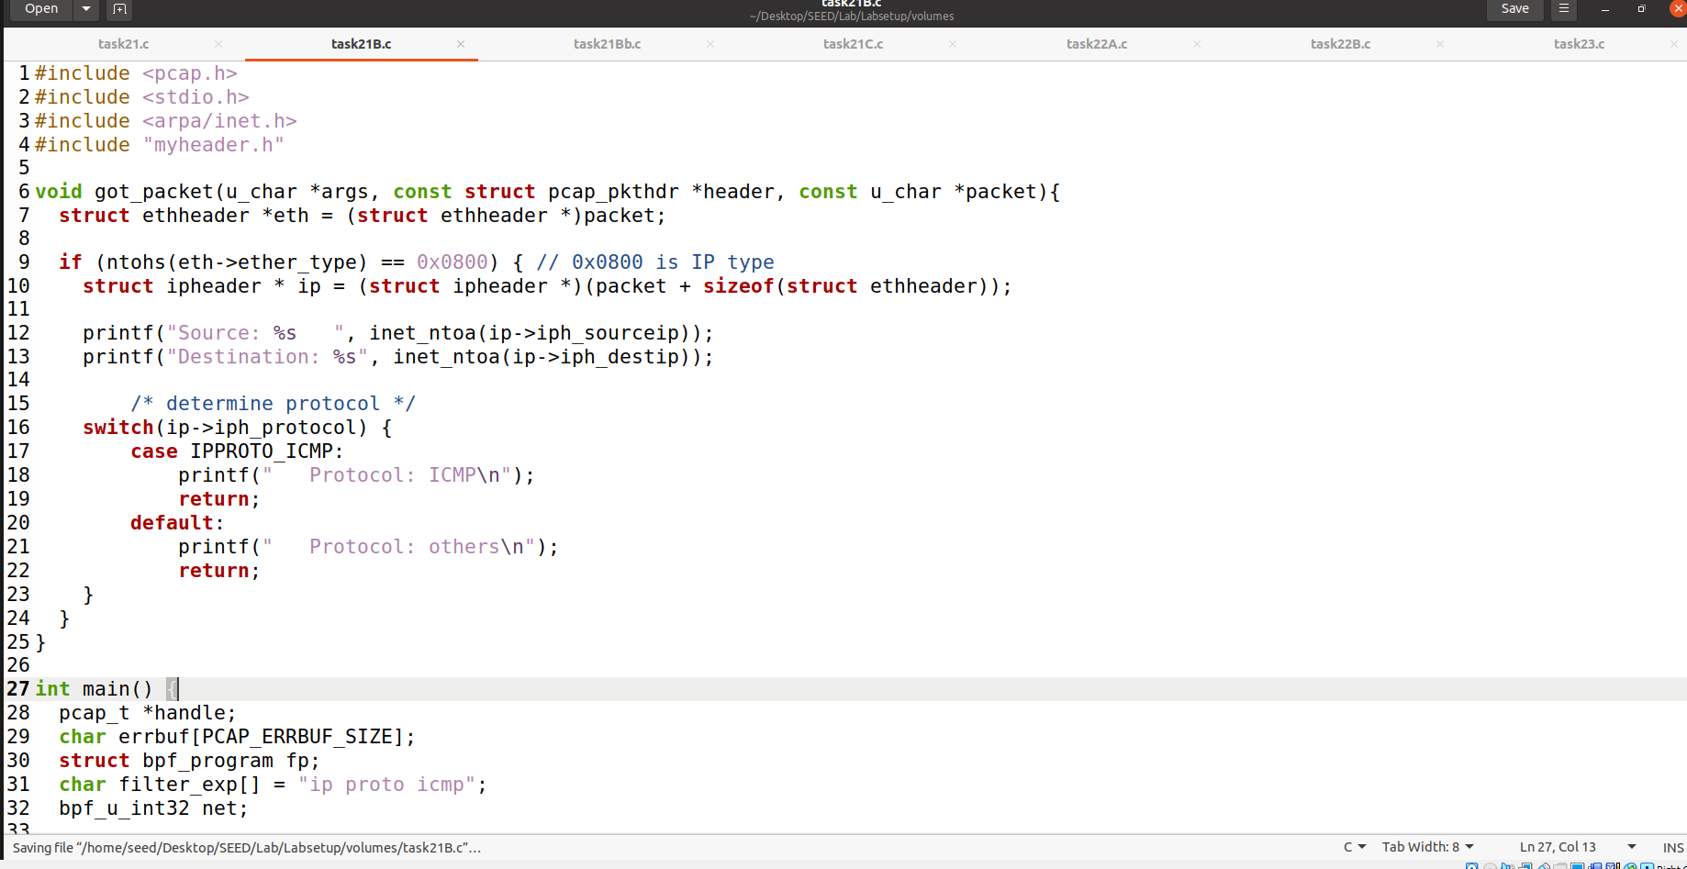

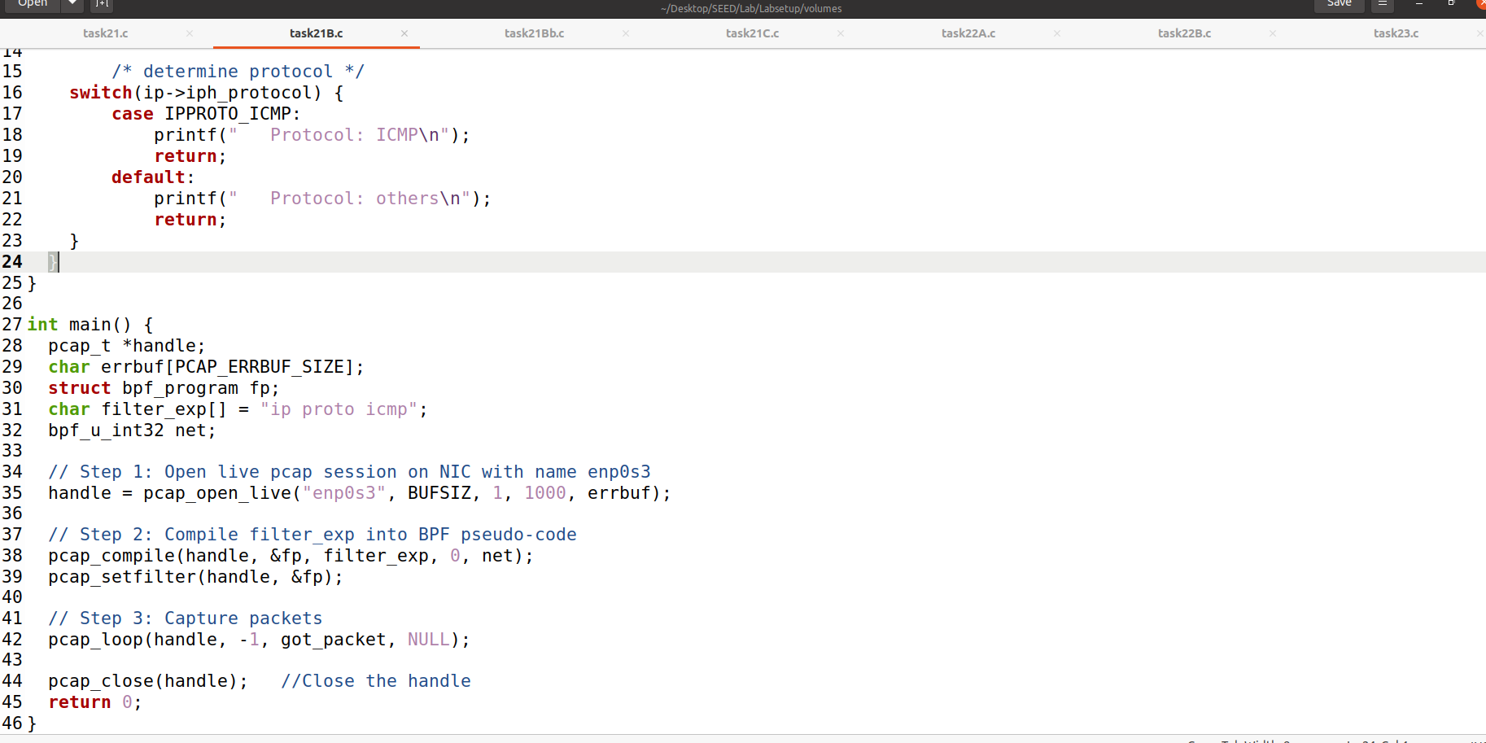

Compiling the program and executing with root privileges.

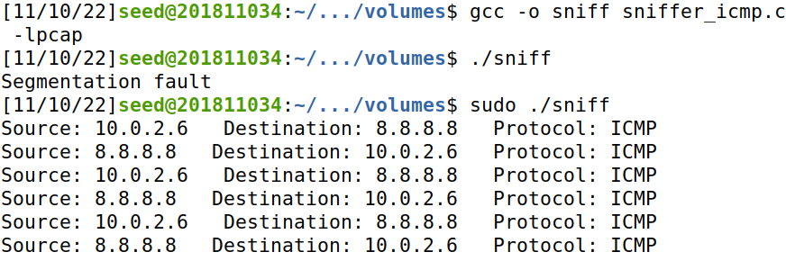

Then I sent 3 packets from HostA terminal to IP 8.8.8.8

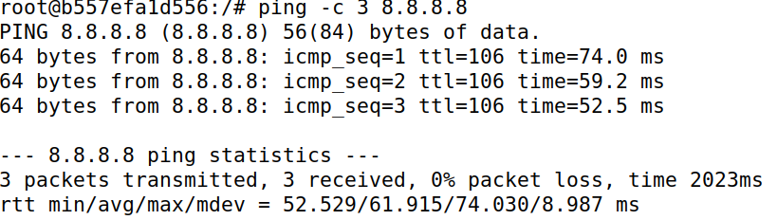

Moving back to the host terminal it is visible that the packets were caught.

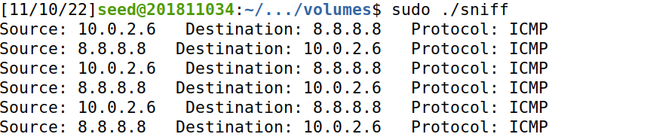

#### Capture the TCP packets with a destination port number in the range from 10 to 100

Wrote the code to capture the TCP packets with a destination port number in the range from 10 to 100.

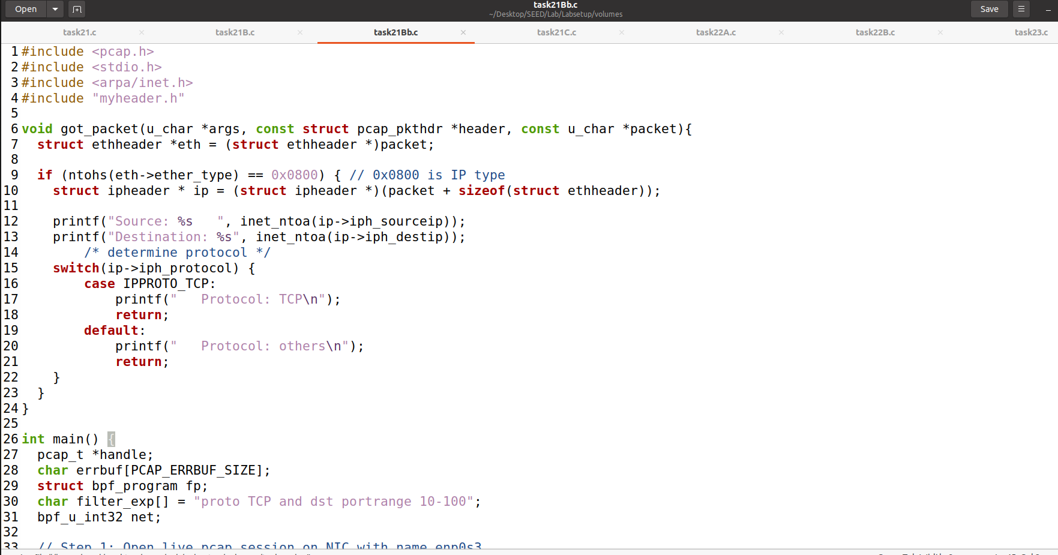

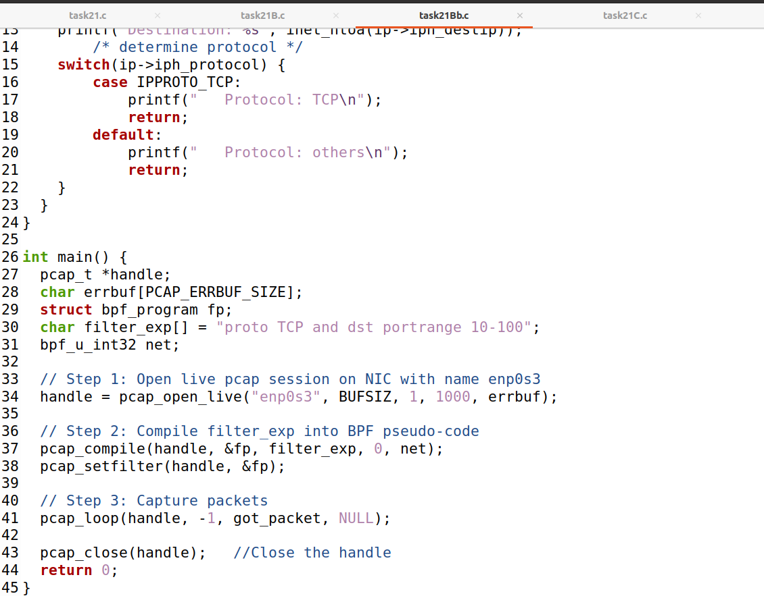

I compiled the code and executed it with root privileges.

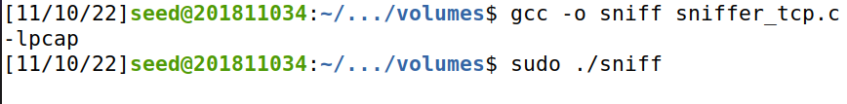

Connected the Host with HostA.

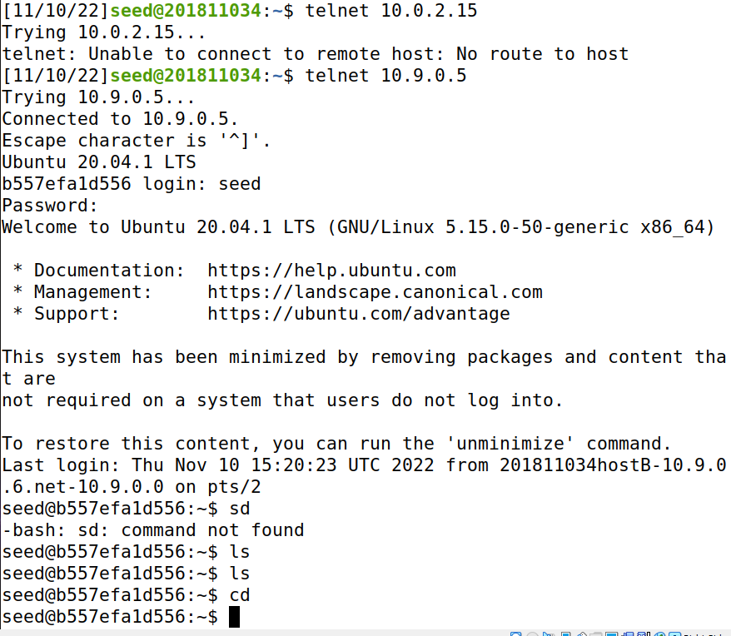

I got these packets as a result after connection and some activity.

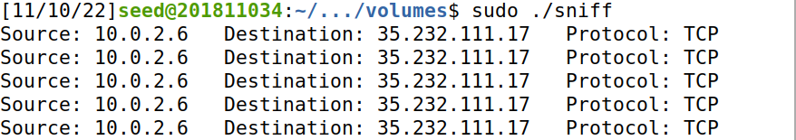

### Task 2.1C

Wrote the code for sniffing passwords.

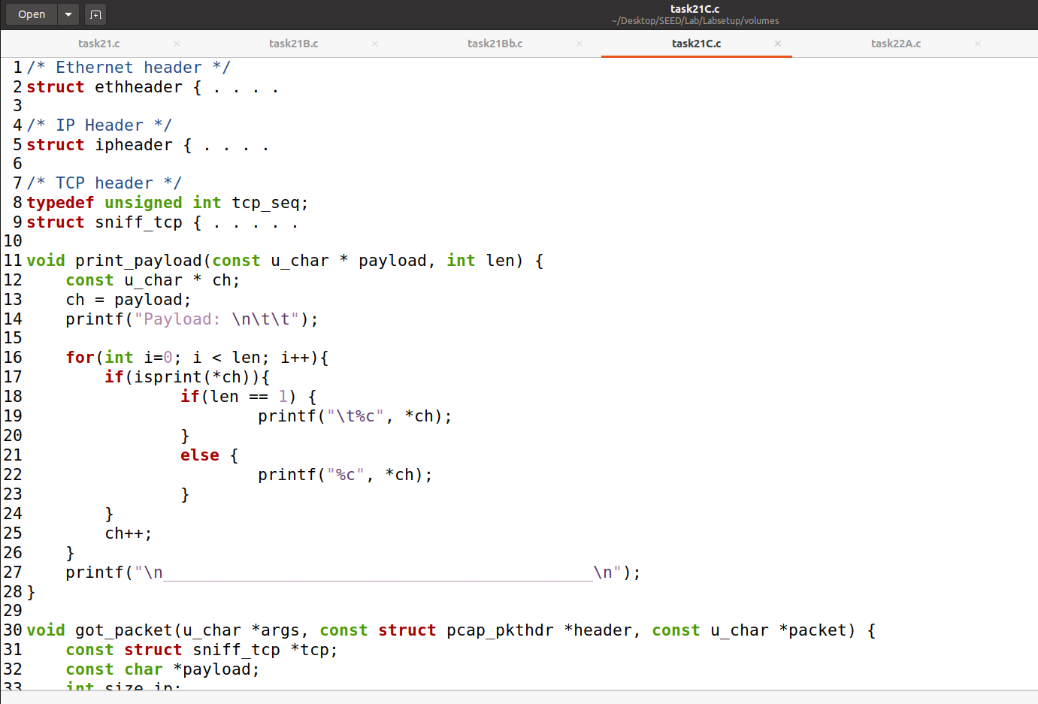

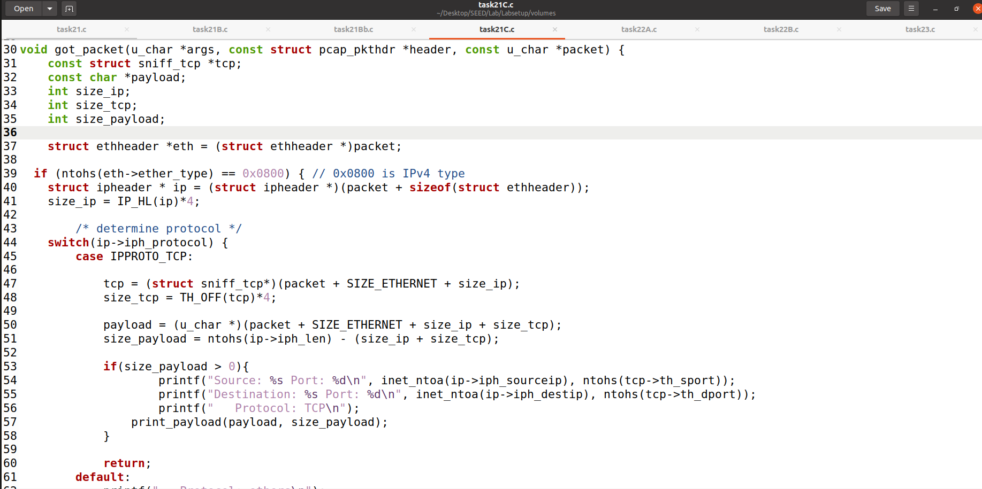

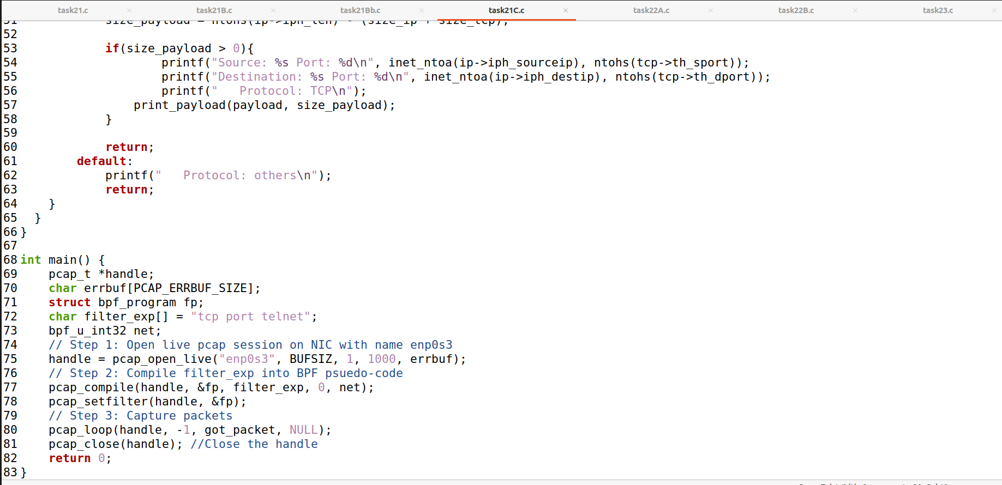

Compiled and executed the code with root privileges.

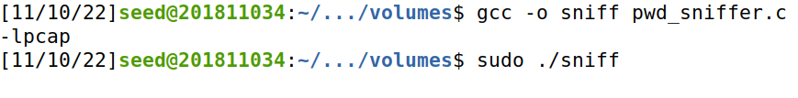

Establishing telnet connection with Host from another VM.

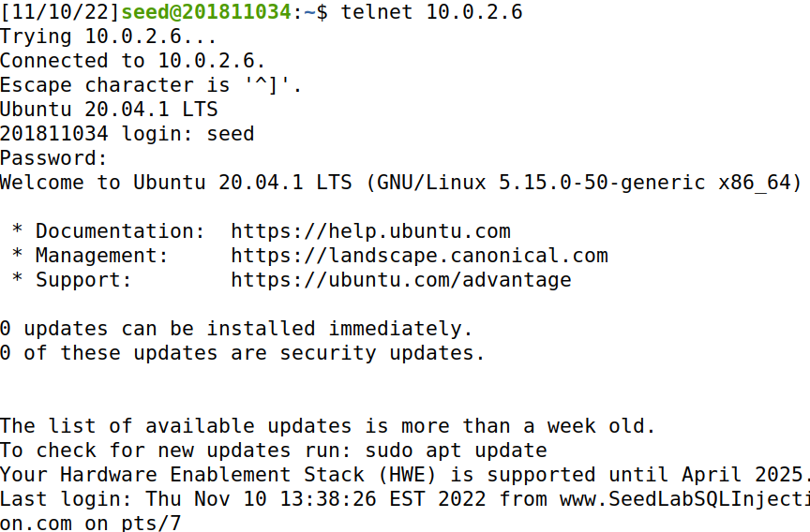

And finally found the password in Host terminal.

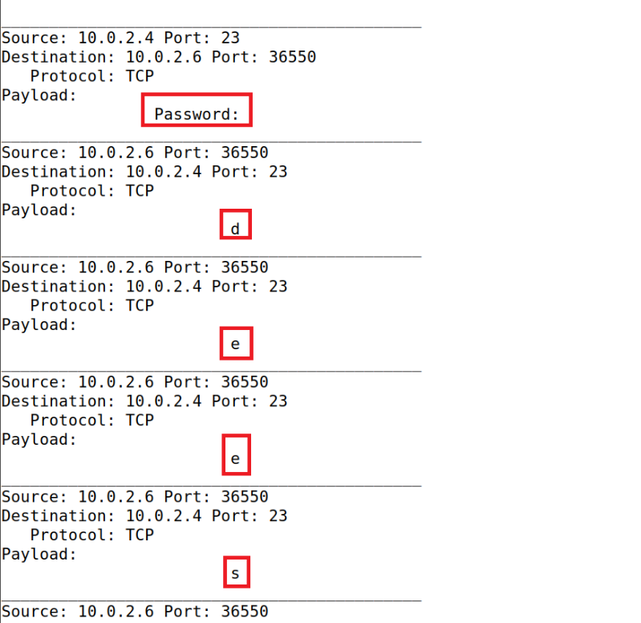

## Task 2.2

### Task 2.2A

I wrote the code for spoofing program.

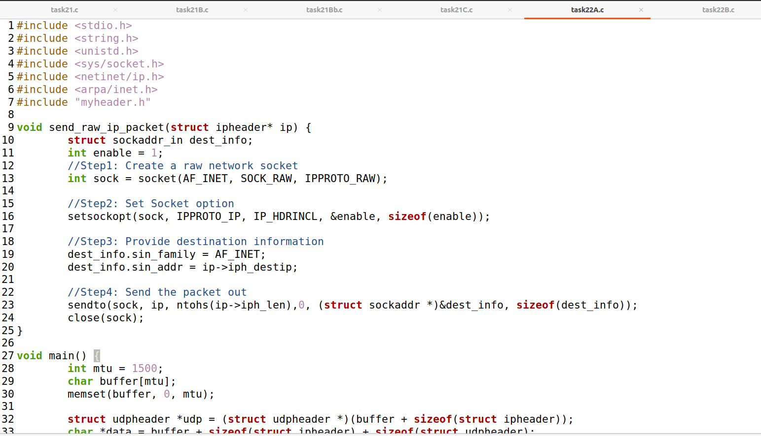

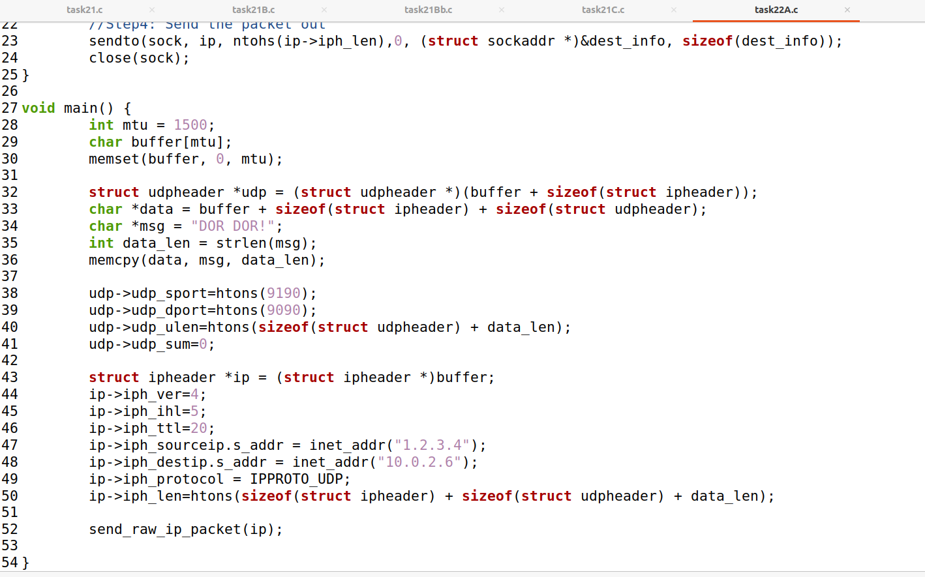

Further when I compiled and executed the program I caught a packet from the source to the destination IP set to 1.2.3.4

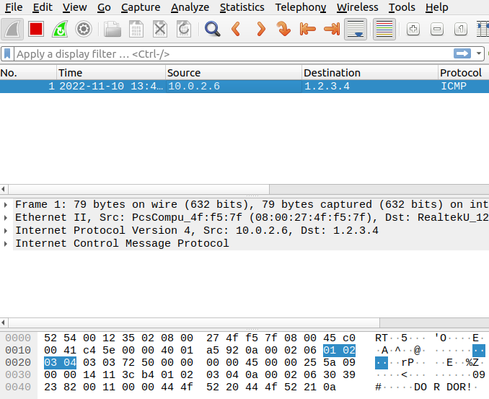

Upon another try I found the UDP packet coming to Host.

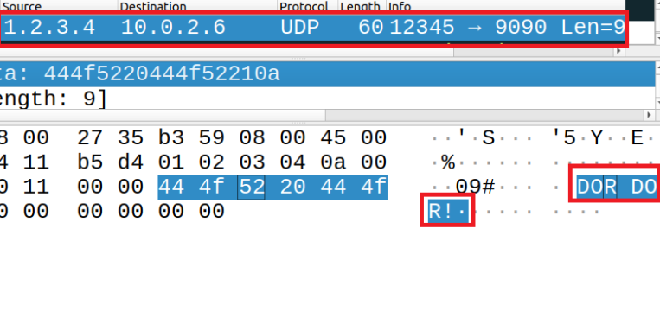

### Task 2.2B

Wrote the code for spoofing an ICMP Echo Request.

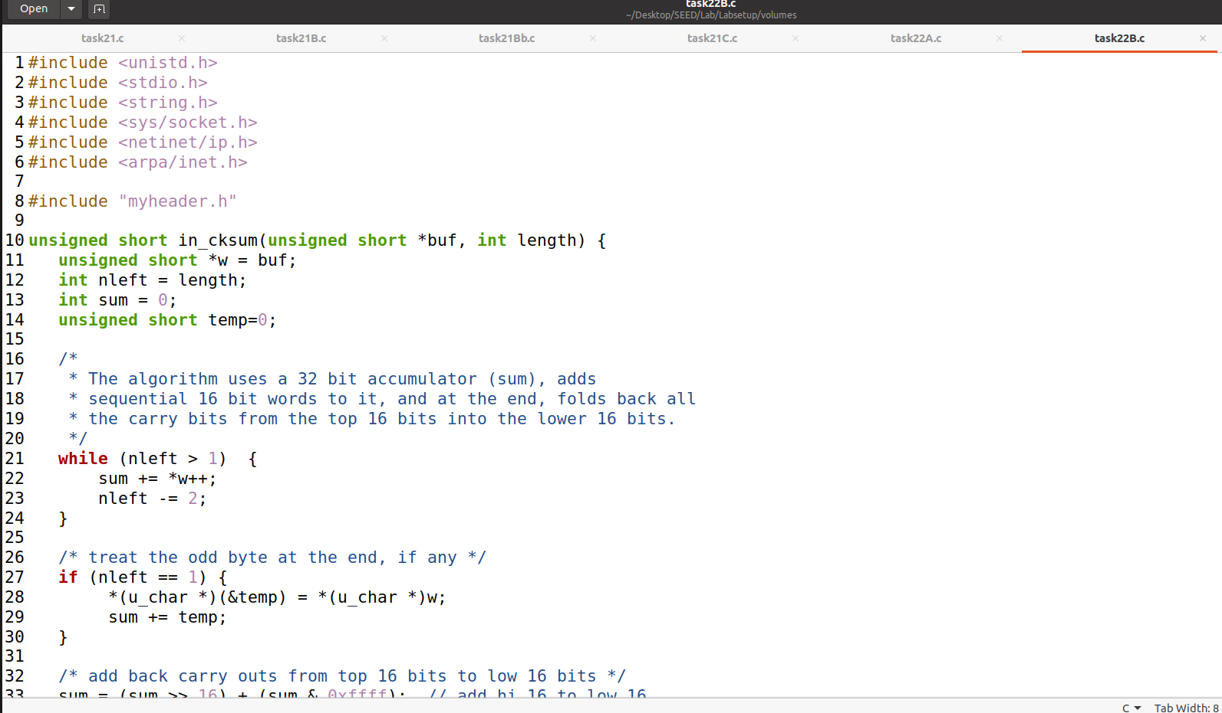

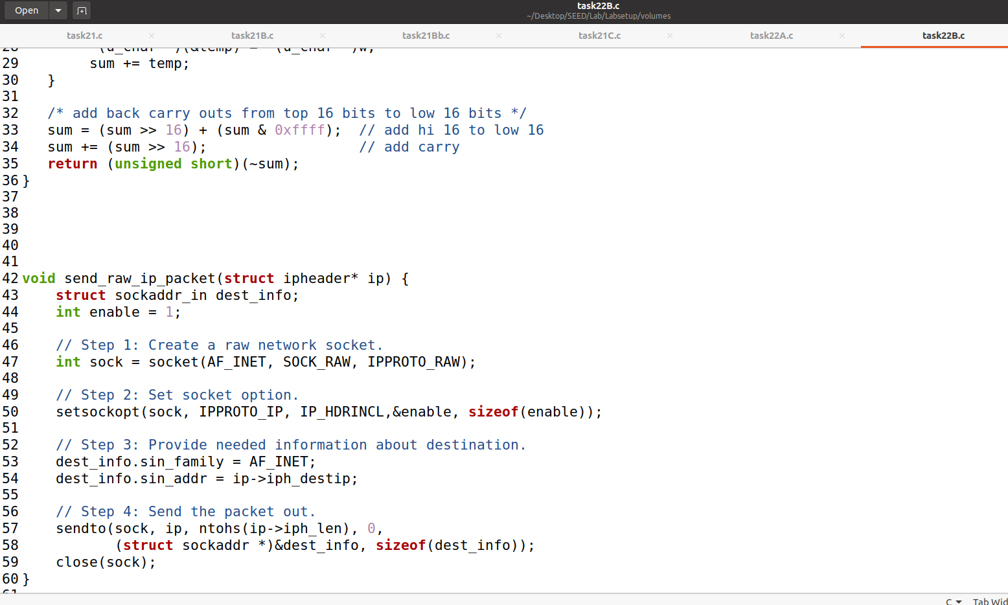

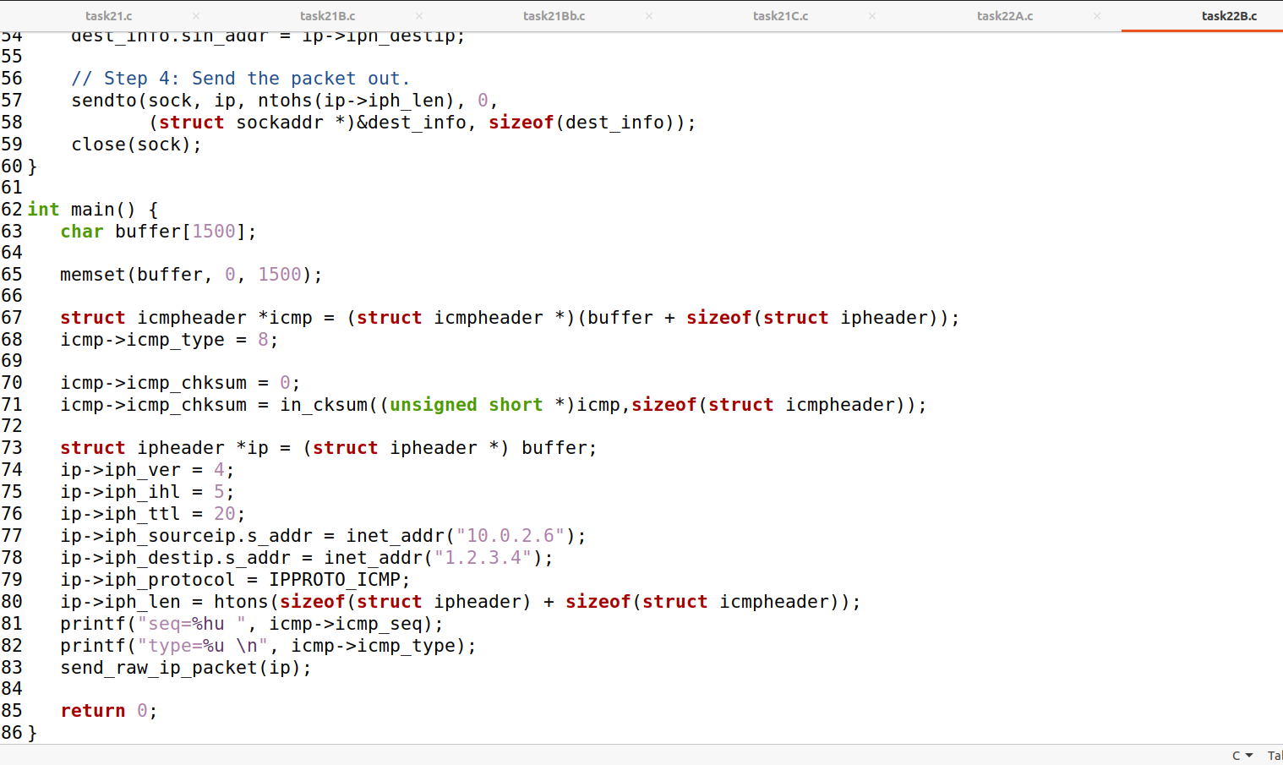

Upon execution I found this activity in wireshark.

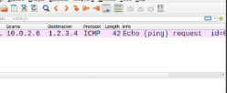

And this in terminal.



#### Question 4

Yes!The IP packet length field can be any arbitrary value. But the packet’s total length is overwritten to its original size when it’s sent.

#### Question 5

When using the raw sockets, you can tell the kernel to calculate the checksum for the IP header. In IP header fields it’s actually the default option, ip_check = 0 will let the kernel do it unless you change it to a different value but then you’ll have to use a checksum method.

#### Question 6

Root privileges are necessary to run programs that implement raw sockets. Normal users do not have the permissions to change all the fields in the protocol headers. Root privileges users can set any field in the packet headers and to access the sockets and put the interface card in promiscuous mode. If we run the program without the root privilege, it will fail at socket setup.

## Task 2.3

Wrote the program for Sniffing and then spoofing.

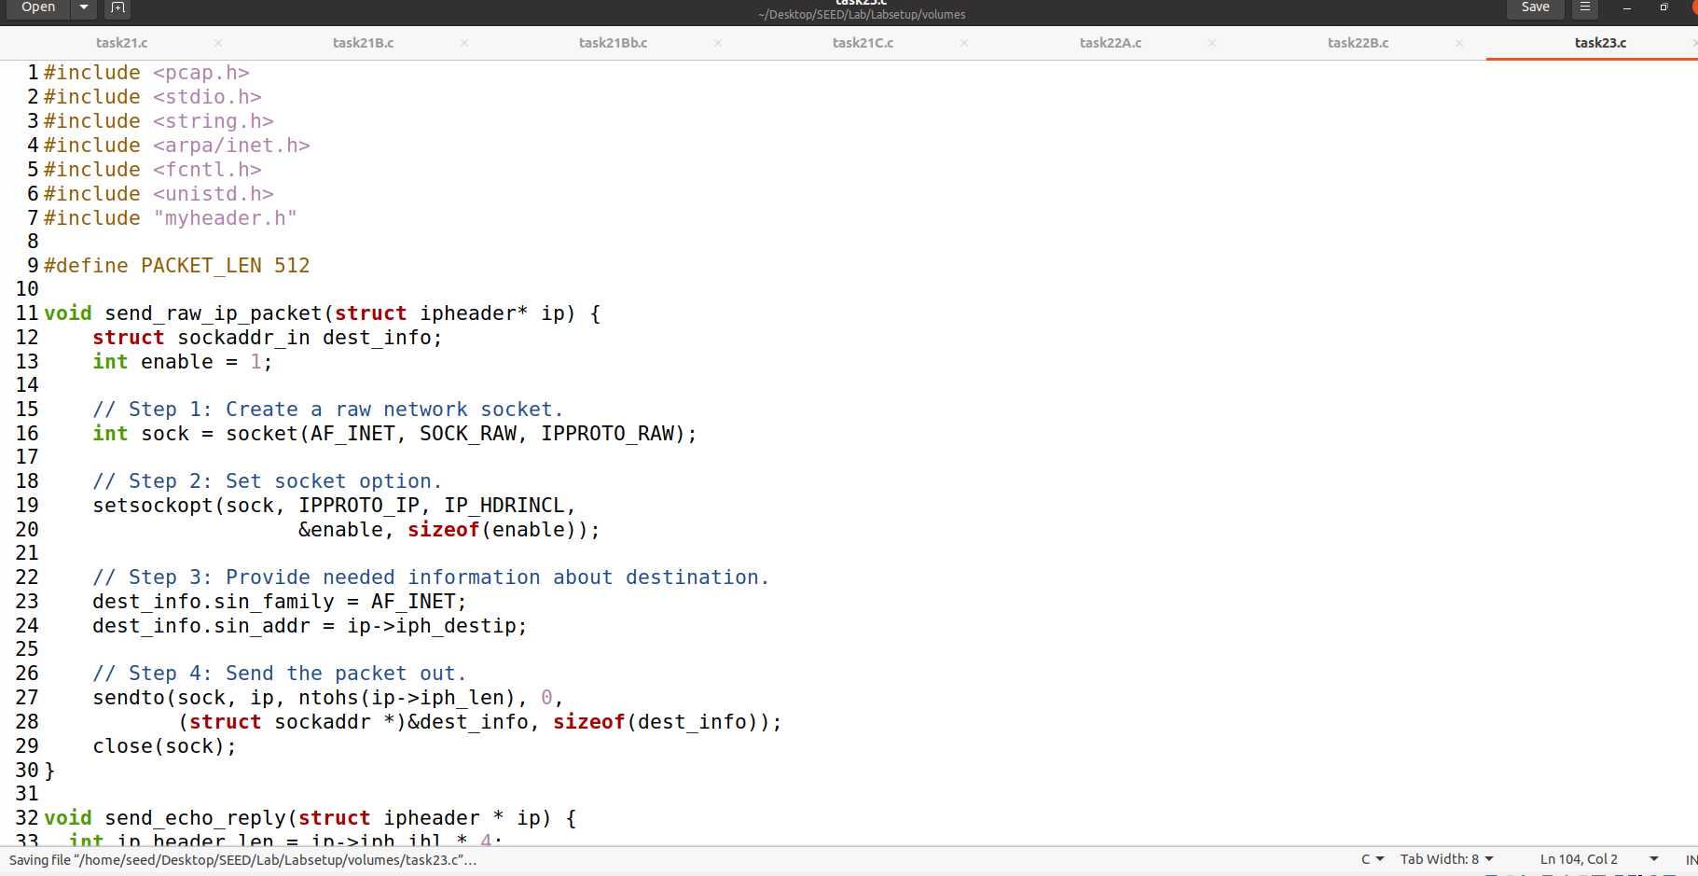

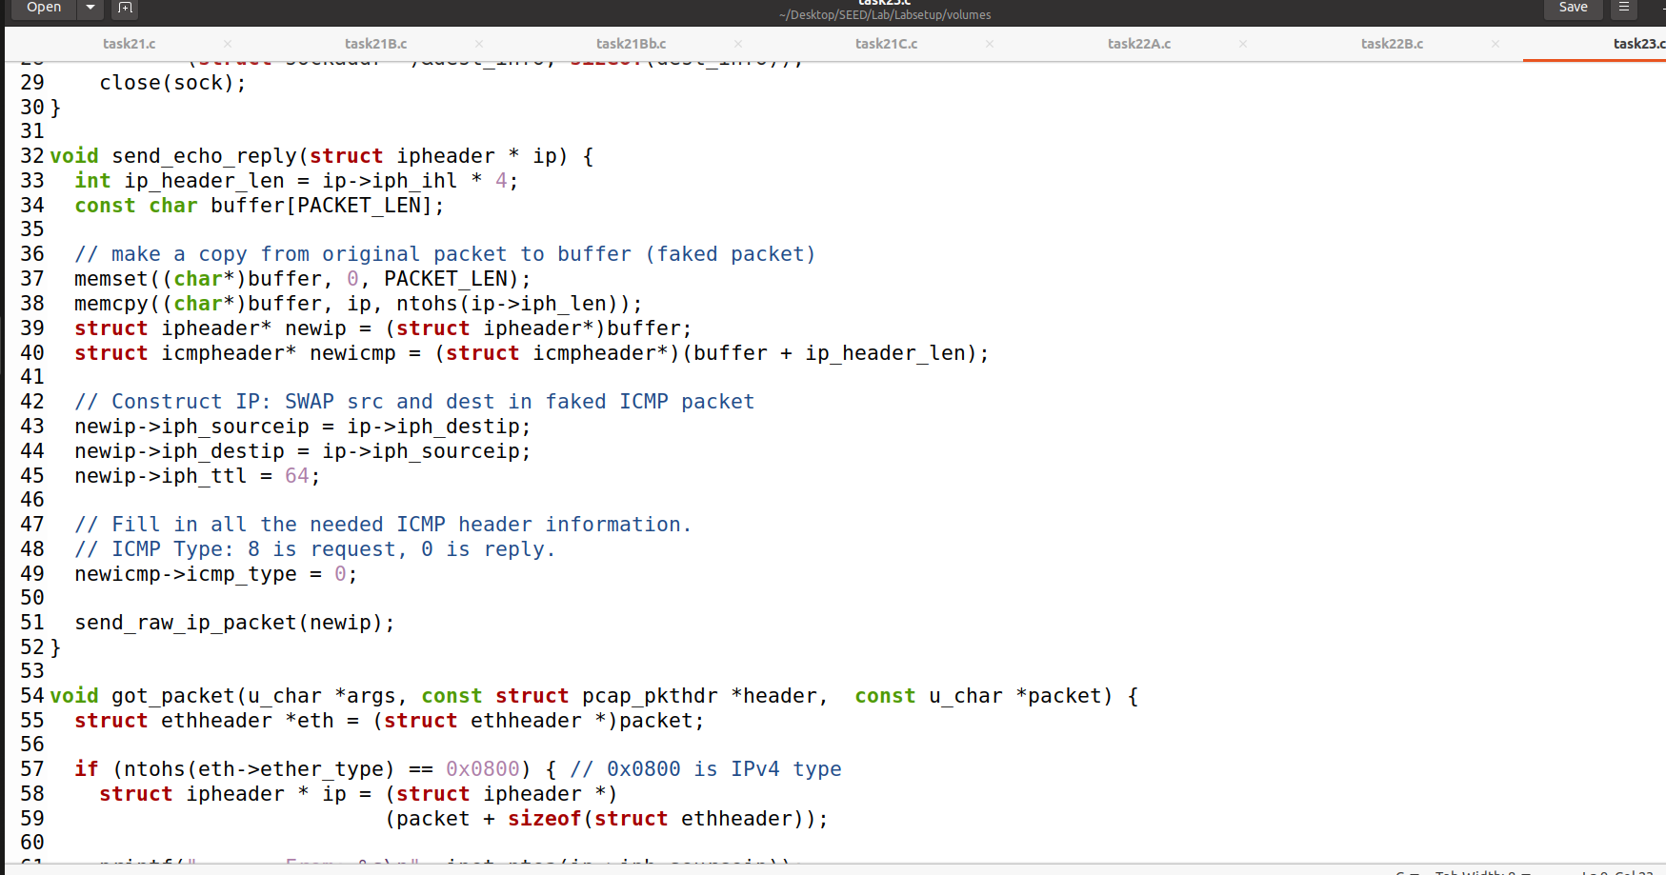

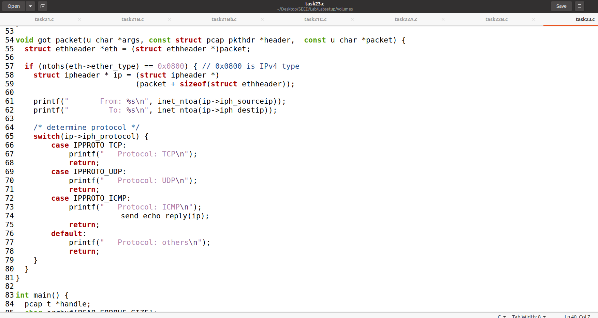

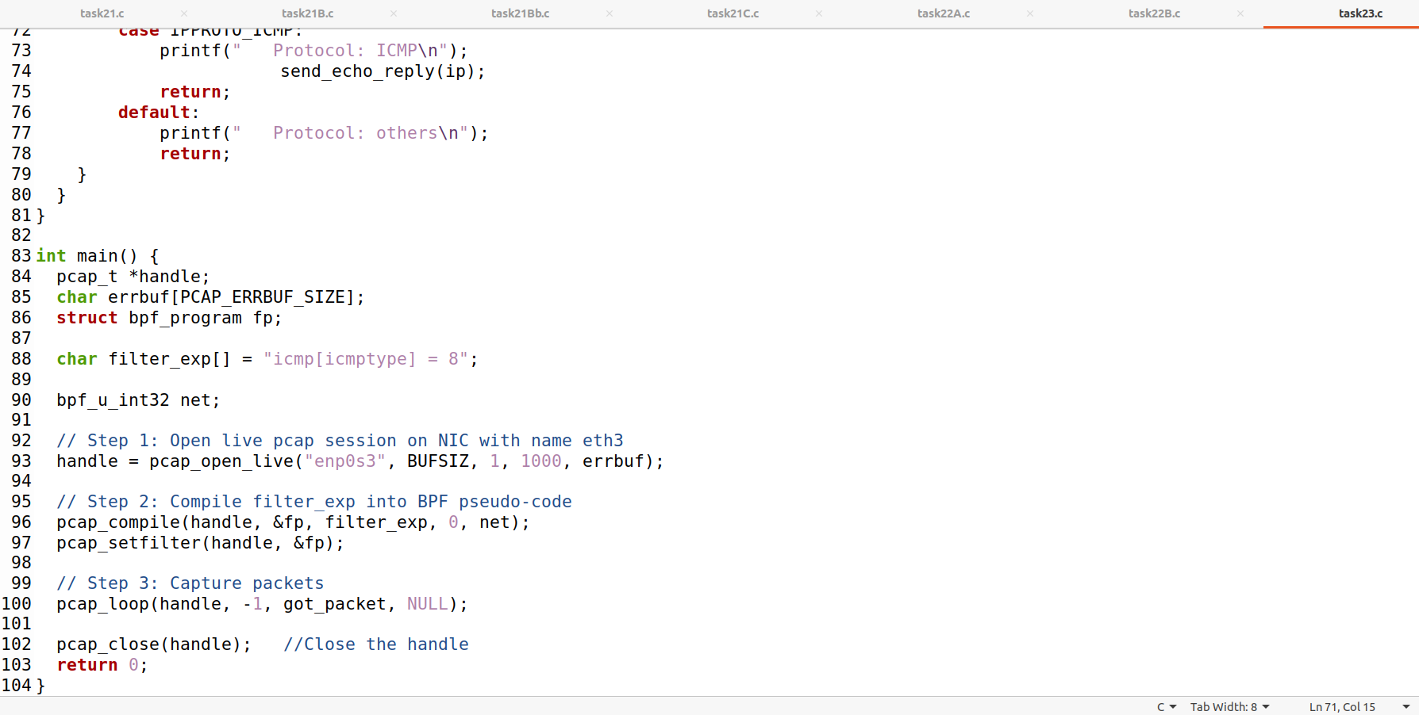

Compiling and executing the code with root privileges.

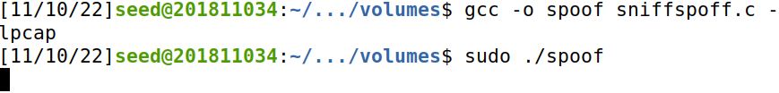

Sending Packets from HostB to IP 8.8.8.8

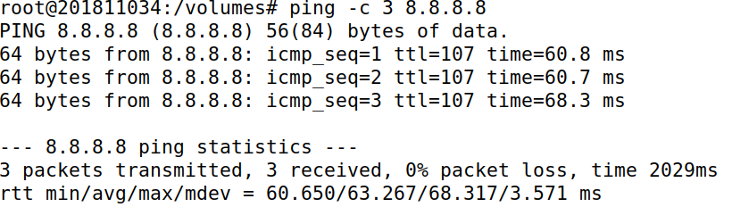

And we get the result.

